HINDU COLLEGE OF PHARMACY

SONIPAT, HARYANA

MANDATORY DISCLOSURE

DIPLOMA IN PHARMACY

(2018-19)

 |  |  | Mandatory Disclosure |  | AUGUST 2018.
 | 1 |  | AICTE File No. |  | 765-62-203(P)/ET/95
 |  |  | Date & Period of Last approval |  | 04 APRIL 2018; 2018-19
 |  | 2 | Name of the Institution |  |  | HINDU COLLEGE OF PHARMACY
 |  |  | Address of the Institution |  |  | NEAR PANCHAYAT BHAWAN, GOHANA
 |  |  |  |  |  | ROAD
 |  |  | City & Pin Code |  |  | SONIPAT – 131001
 |  |  | State/ UT |  |  | HARYANA
 |  |  | Phone number with STD code |  | 0130-2221072
 |  |  | Fax number with STD code |  | 0130-2221568
 |  |  | Office hours at the institution |  |  | 9:00 am – 4:30 pm
 |  |  | Academic hours at the Institution |  |  | 9:15 am- 4:15pm
 |  |  | Email |  |  | hcpsnp@hry.nic.in
 |  |  | Website |  |  | www.hcpsonepat.org
 |  |  | Nearest Railway Station (Km) |  |  | Sonepat (1 km)
 |  |  | Nearest Airport (Km) |  |  | Indira Gandhi International Airport, Delhi
 |  |  |  |  |  | (63 Km)
 | 3 |  | Type of Institution |  | Private- Self Financed
 |  |  | Category (1) of the Institution |  | Non Minority
 |  |  | Category (2) of the Institution |  | Co-Ed
 |  |  |  | \

 | 4 |  | Name of the organization running the |  |  | The Sonepat Hindu Educational & Charitable
 |  |  | institution |  |  | Society, Sonipat
 |  |  | Type of the organization |  |  | Society
 |  |  | Address of the organization |  |  | Hindu College, Rohtak Road, Sonipat, Haryana
 |  |  |  | 131001
 |  |  | Registered with |  |  | Office of the Registrar, Firms & Societies,
 |  |  |  |  |  | Haryana
 |  |  | Registration date | 04/06/1980
 |  |  | Website of the organization |  |  | http://www.vidyasonepat.com
 |  |  | Name of the affiliating Board |  | Haryana State Board of Technical Education
 |  |  | Address |  | Bays 7-12, Sector- 4, Panchkula, Haryana
 |  |  | Website |  | www.hsbte.org
 |  |  | Latest affiliation period | 2018-19
 | 6 |  | Name of Principal/Director |  | Dr. (Mrs.) Saroj Jain
 |  |  | Exact Designation |  | Principal
 |  |  | Phone number with STD code | 0130-2221568
 |  |  | Fax number with STD code | 0130-2221568
 |  |  | Email |  | sarojhcp@yahoo.com
 |  |  | Highest Degree |  | Ph. D.
 |  |  | Field of specialization |  | Pharmaceutical Sciences
 | 7 |  | Governing Board Members |  | Annexure I
 |  |  | Frequency of meetings & date of last |  | Twice a year.
 |  |  | meeting

8 | Academic Advisory Body |  |  | 1. Prof. D. N. Mishra, G.J.U.S.&T., Hissar
 |  |  |  | 2. Prof. Asgar Ali, Jamia Hamdard, Delhi
 |  |  |  | 3. Prof. S.H. Ansari, Jamia Hamdard, Delhi
 | Frequency of meetings & date of last |  |  | Once a year
 | meeting
9 | Organizational Chart |  |  | Annexure II
10 | Student feedback mechanism on |  |  | A feedback form, having questions relating to
 | institutional | Governance/ | faculty | course and evaluation plan, text and reference
 | performance |  |  | books followed and suggested, syllabus coverage,
 |  |  |  | is provided to the students. After proper scrutiny of
 |  |  |  | the feedback forms, appropriate steps are taken.
11 | Grievance | redressal mechanism for |  | Periodic meetings of the staff and faculty are held
 | faculty, staff and students |  |  | under the Chairmanship of the Principal to redress
 |  |  |  | the grievances, if any. A student grievance
 |  |  |  | redressal committee is also constituted and wide
 |  |  |  | publicity is given by displaying on notice board
 |  |  |  | and institutional website.
12 | Name of the Department |  |  | Pharmacy
 | Course |  |  | D. Pharm.
 | Level |  |  | UG
 | 1st Year of approval by the Council |  |  | 1995
 | Year wise Sanctioned Intake |  |  | 60 CAY | 60 CAY₋₁ | 60 CAY₋₂
 | Year wise actual admissions |  |  | 60 CAY 60 CAY₋₁ |  | 60 CAY₋₂
 | Cut off marks- General Quota |  |  | 68.2 CAY | 66 CAY₋₁ | 65 CAY₋₂
 | % Students passed with distinction |  |  | 12.5 CAY | 10.8 CAY₋₁ | 5.1 CAY₋₂
 | % Students passed with First Class |  |  | 29.1 CAY 43.4 CAY₋₁ |  | 48. CAY₋₂

 |  |  | Students Placed |  |  | 36 CAY | 39 CAY₋₁ |  | 28 CAY₋₂
 |  |  | Average Pay package Rs./ Year |  | 1.80 lac CAY 1.50 lac CAY₋₁ 1.40 lac CAY₋₂
 |  |  | Students opted for Higher Studies |  |  | 06 CAY | 12 CAY₋₁ |  | 06 CAY₋₂
 |  |  | Accreditation Status of the Course |  | Not Accredited
 |  |  | Doctoral Course |  | No
 |  |  | Foreign collaborations, if any |  | No
 |  |  | Professional Society Memberships |  | No
 |  |  | Professional activities |  | National Pharmacy Week Celebrations  Pharmacist Day Celebration  Teachers day celebration
 |  |  | Consultancy activities |  | None
 |  |  | Grants fetched |  | None
 |  |  | Departmental achievements | Ph.D awarded to Mr. Bharat Bhushan
 |  |  | Distinguished Alumni | -
 | 13 |  | Teaching Staff Detail |  |  | Annexure III
 | 14 |  | Admission Quota |  | D. Pharm.
 |  |  | Entrance test/ admission critera |  | Through merit prepared by Haryana State
 |  |  |  |  | Counseling Society on the basis of Senior
 |  |  |  |  | Secondary marks. For 25% Management quota
 |  |  |  |  | seats, admission are made through merit prepared
 |  |  |  |  | on the basis of Qualifying Exam (12th).
 |  |  | Cut off last candidate admitted |  |  | 47% CAY |  | 45% CAY₋₁ 45% CAY₋₂
 |  |  | Fees in rupees | 30150/-
 |  |  | Number of Fee Waivers offered |  |  | 0 CAY |  | 0 CAY₋₁ | 0 CAY₋₂
 |  |  | Admission Calender |  | June - August
 |  |  | PIO Quota |  | NO

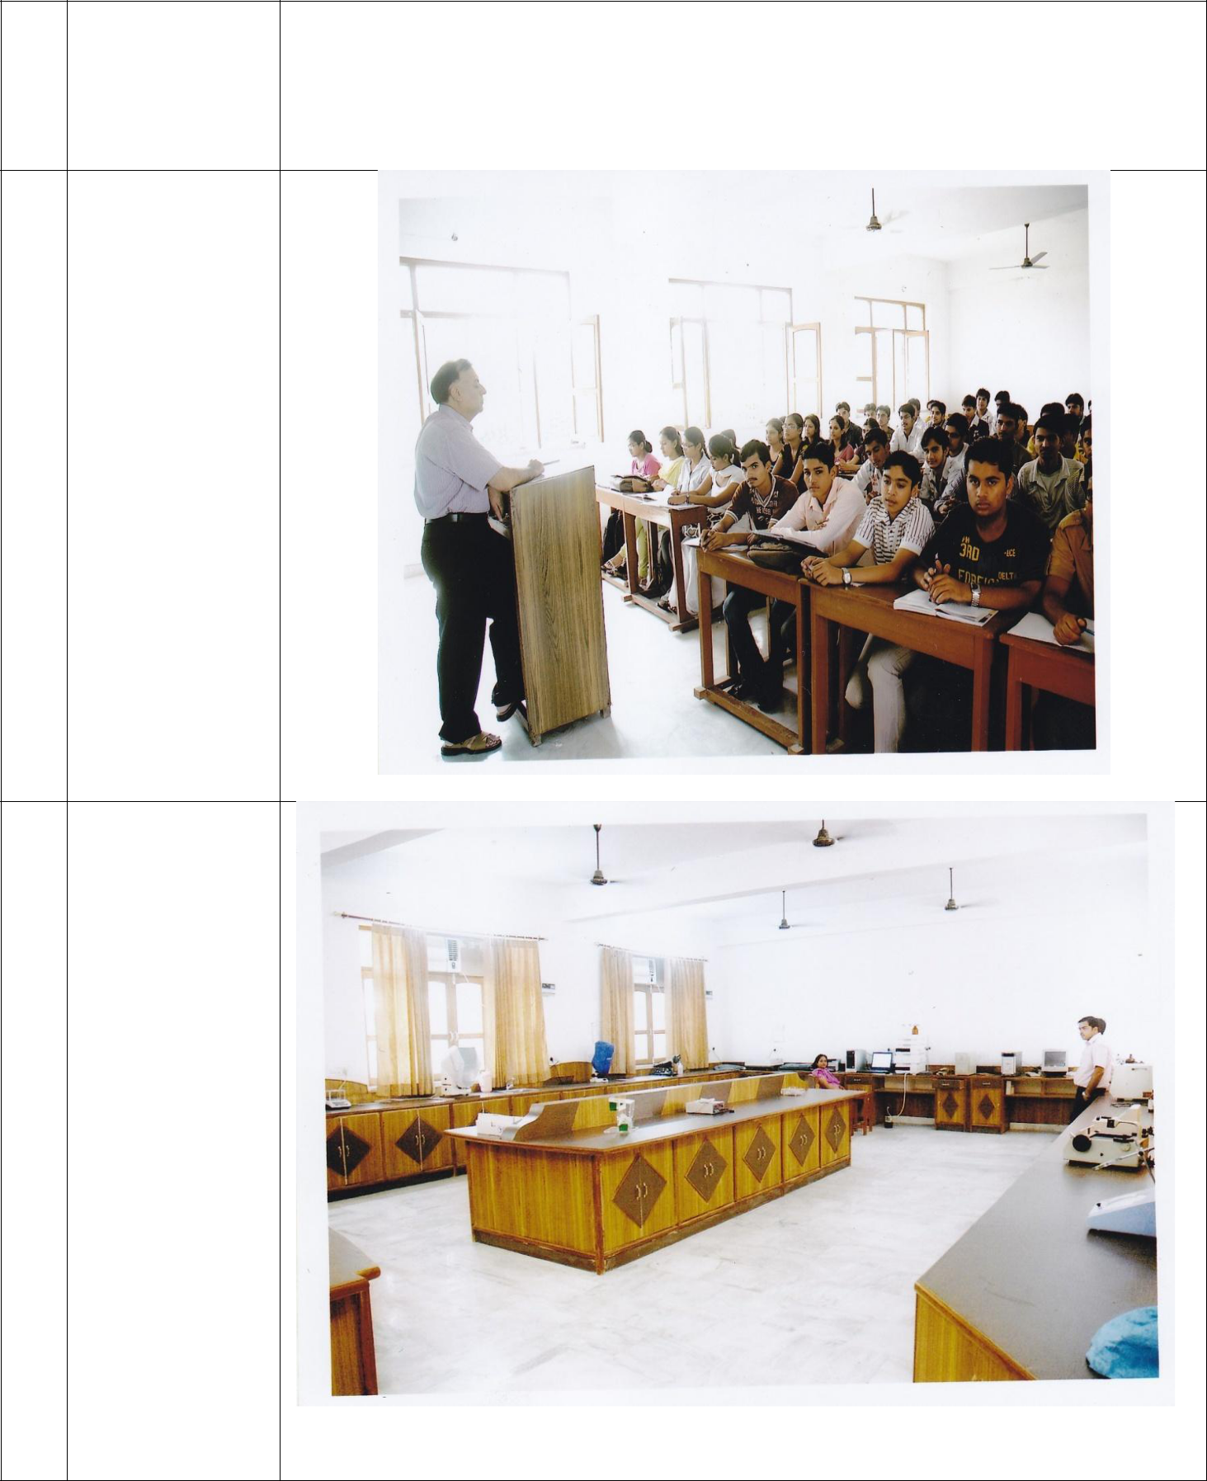
- Infrastructural Information

Classroom/ Tutorial Room facilities

Laboratory

Details

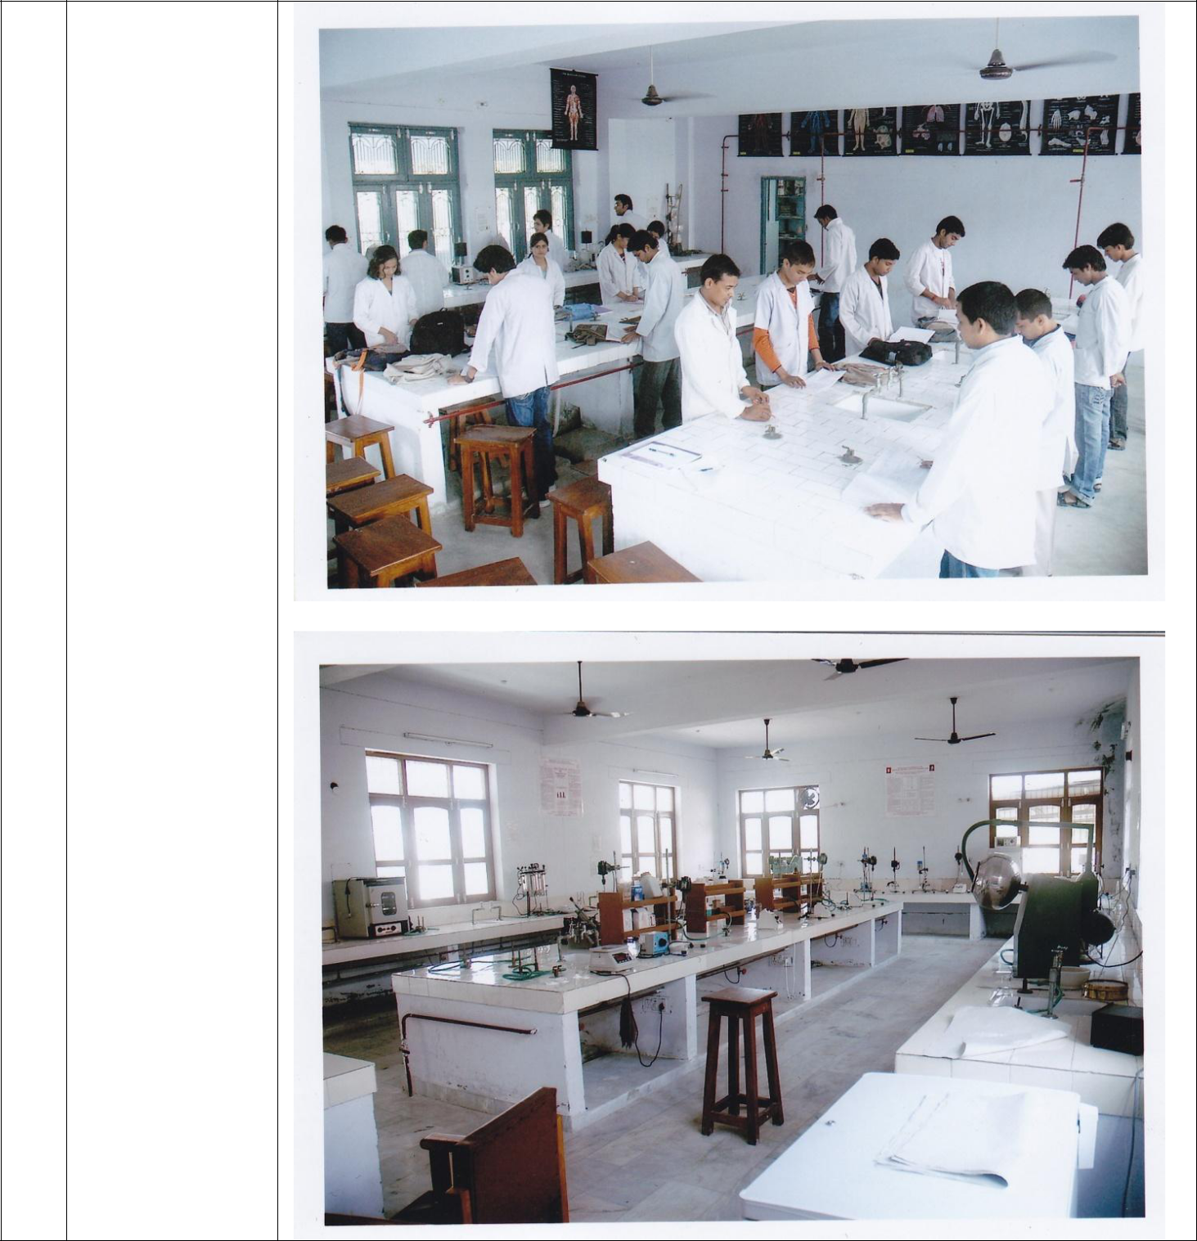
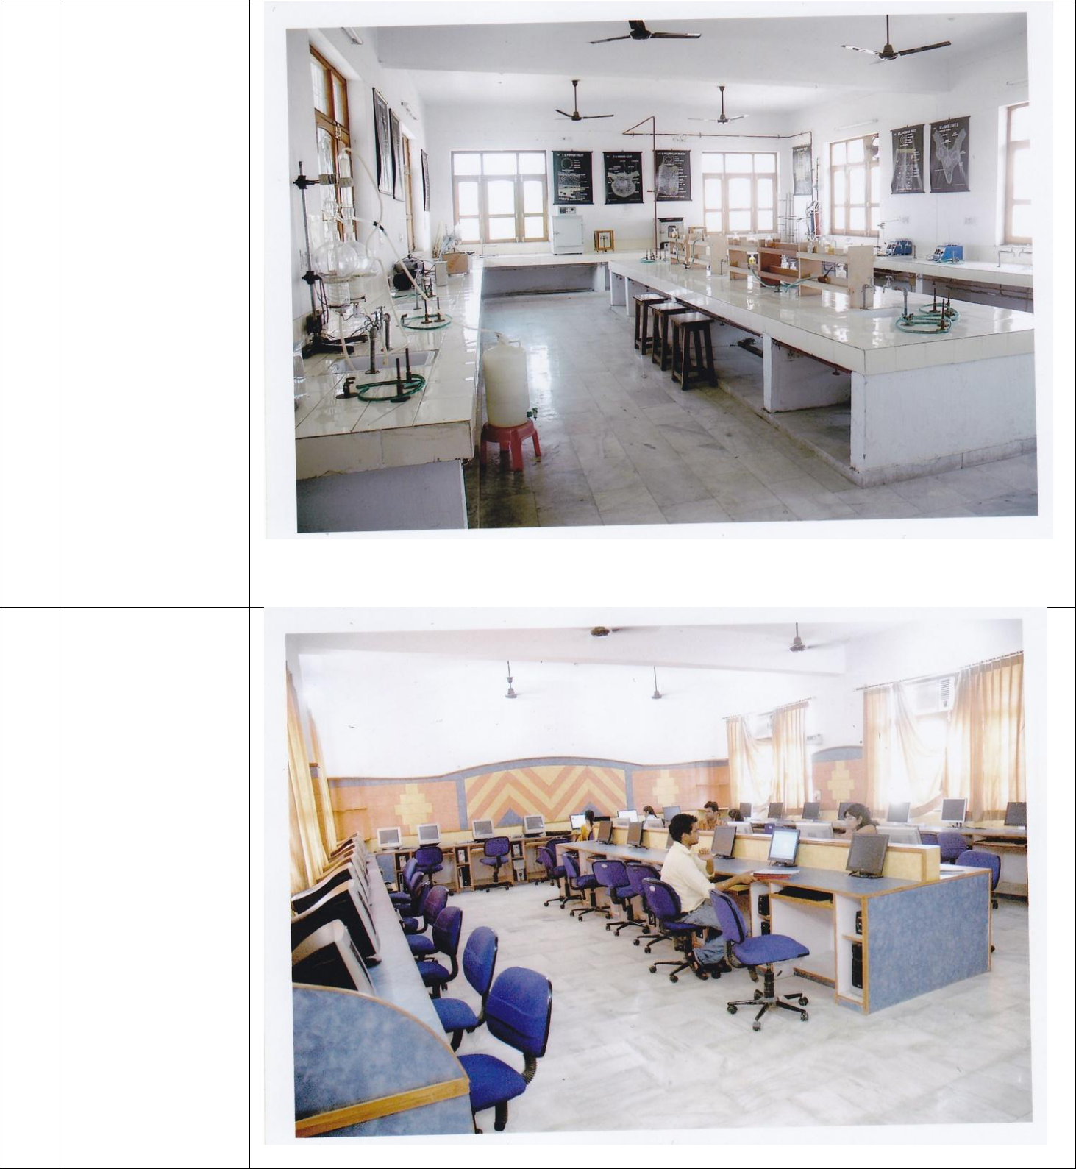

Computer

Center

facilities

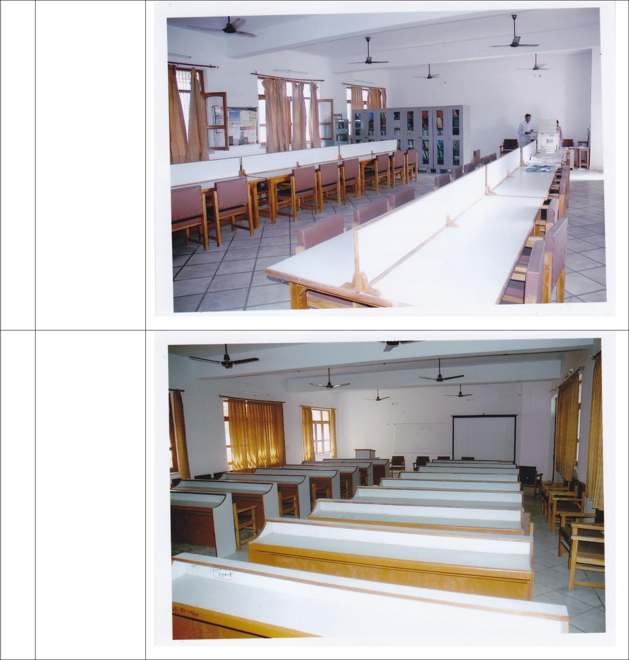
Library

facilities

Auditorium/ Seminar Hall

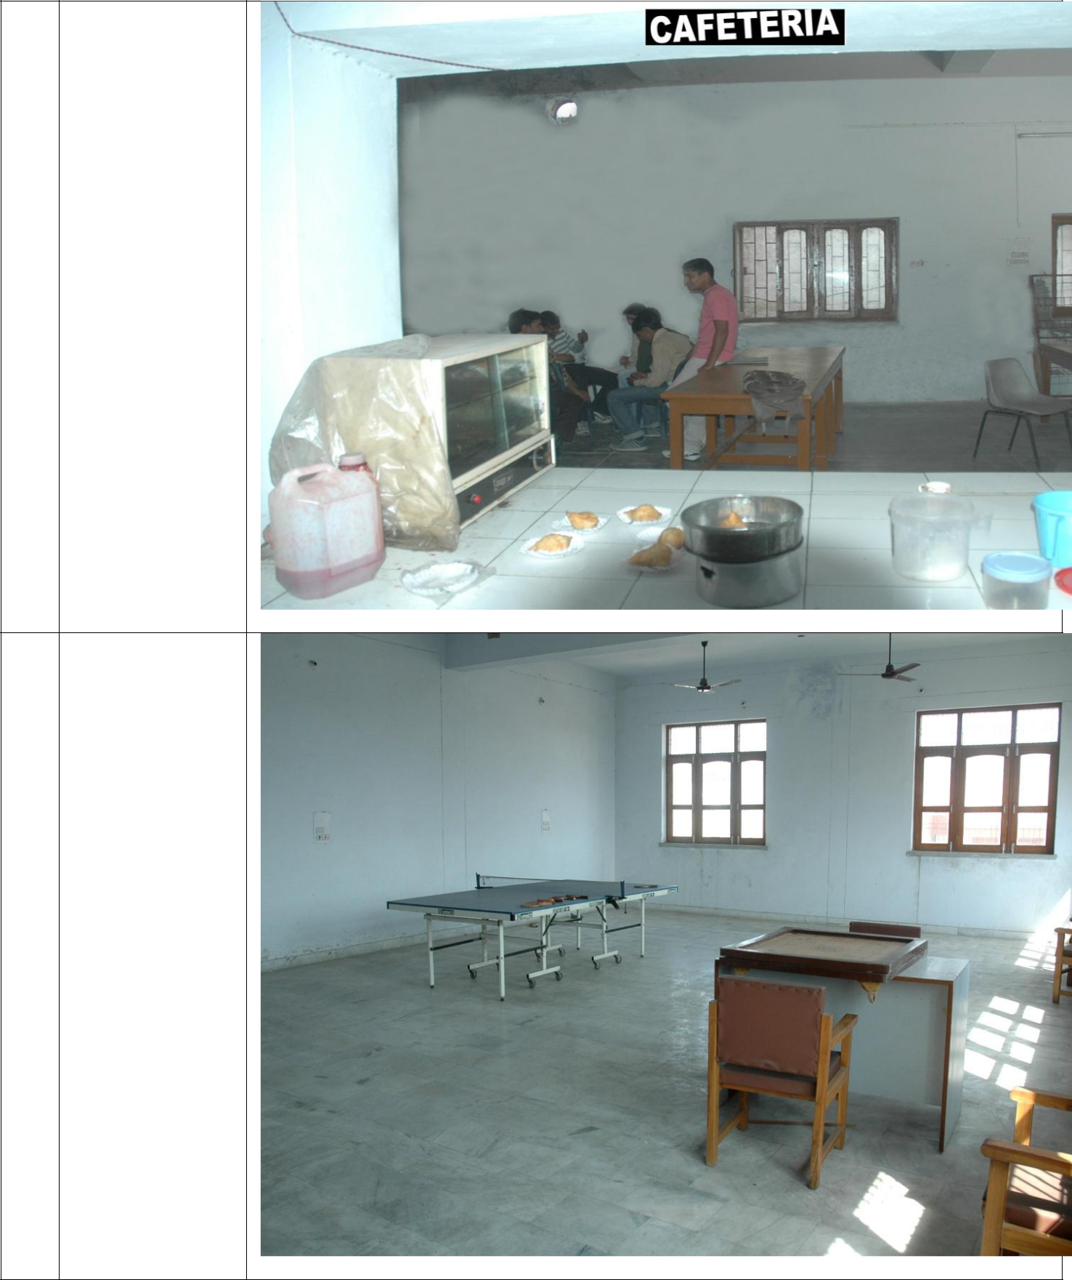
Cafetaria

Indoor Sport facilities

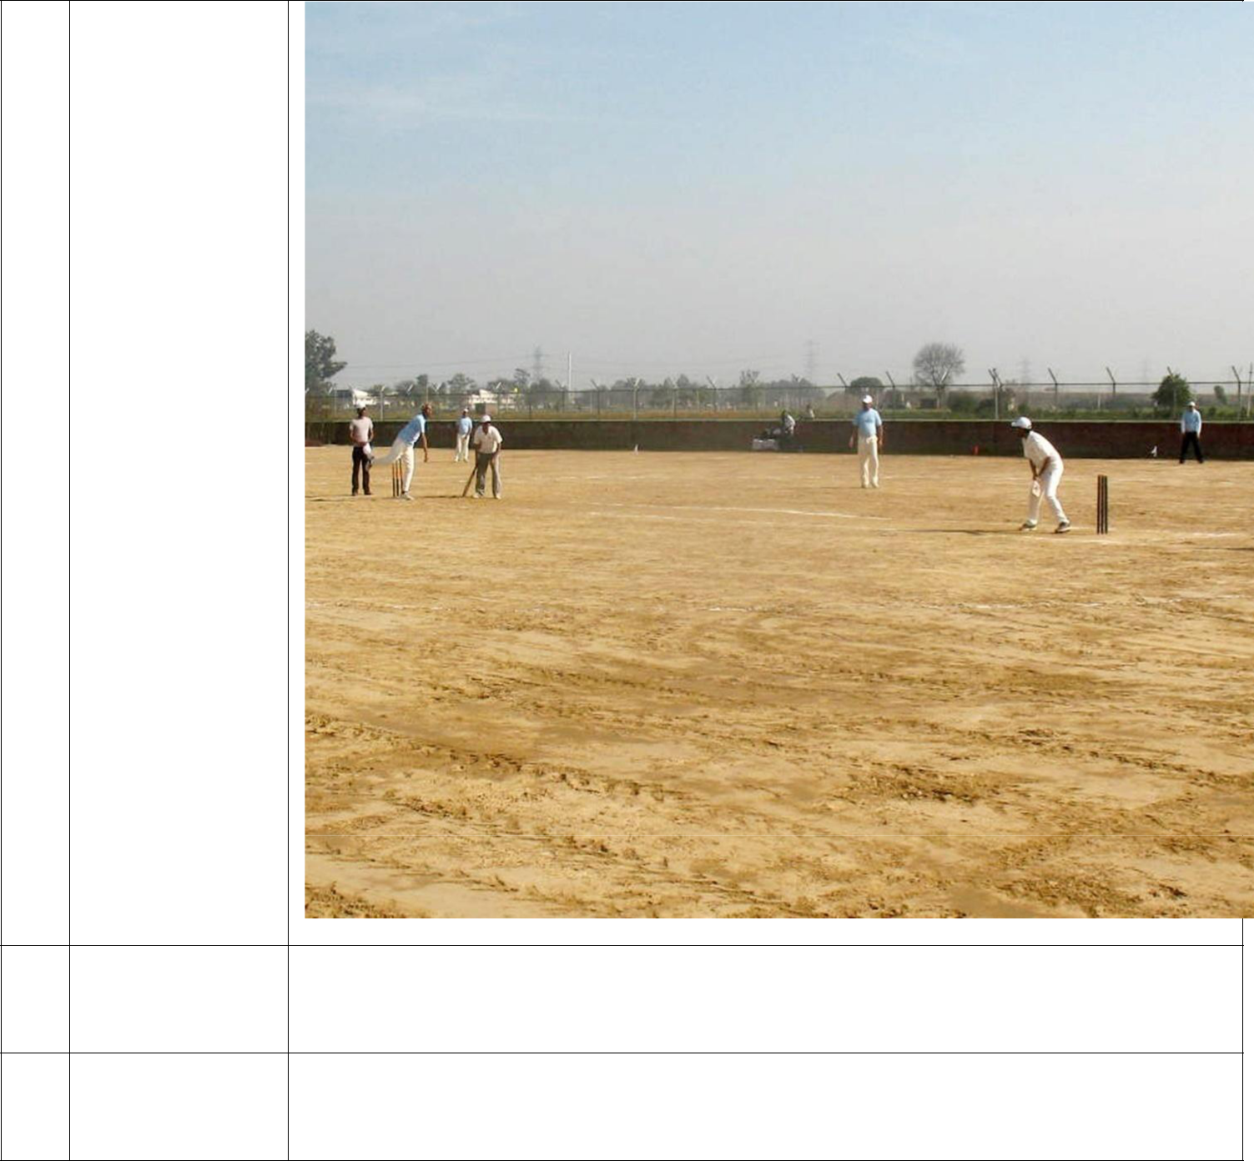
Outdoor Sports facilities

Gymnasium Available

facilities

Facilities for Available

disabled

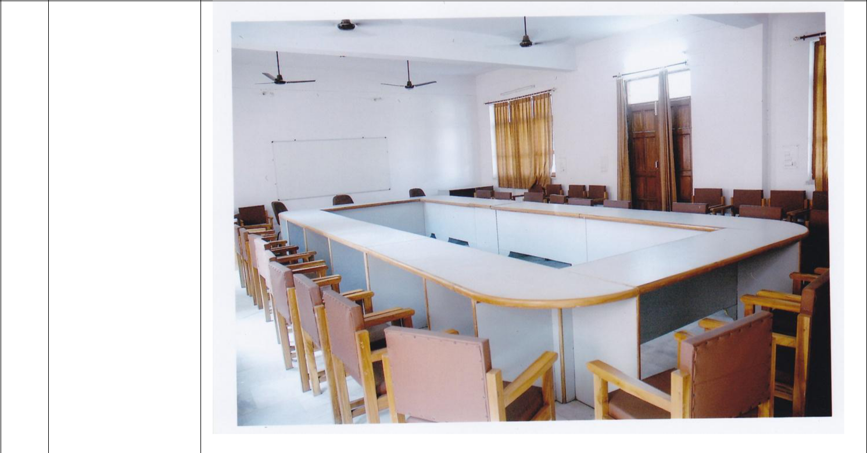
Any other facilities

- Boys Hostel
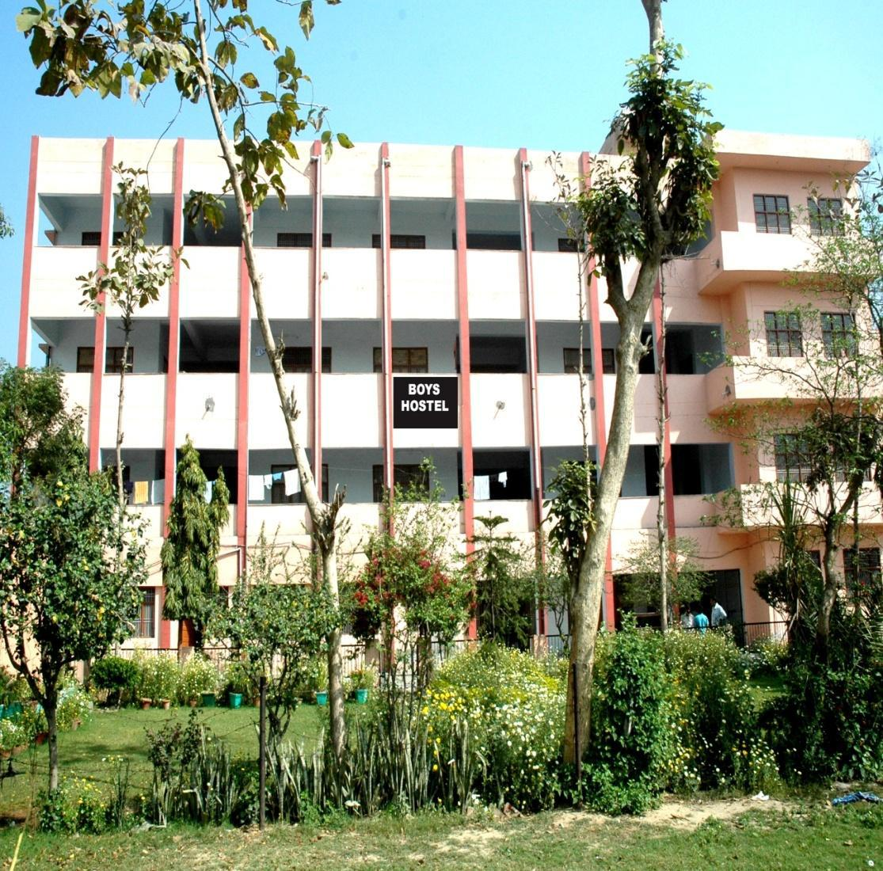

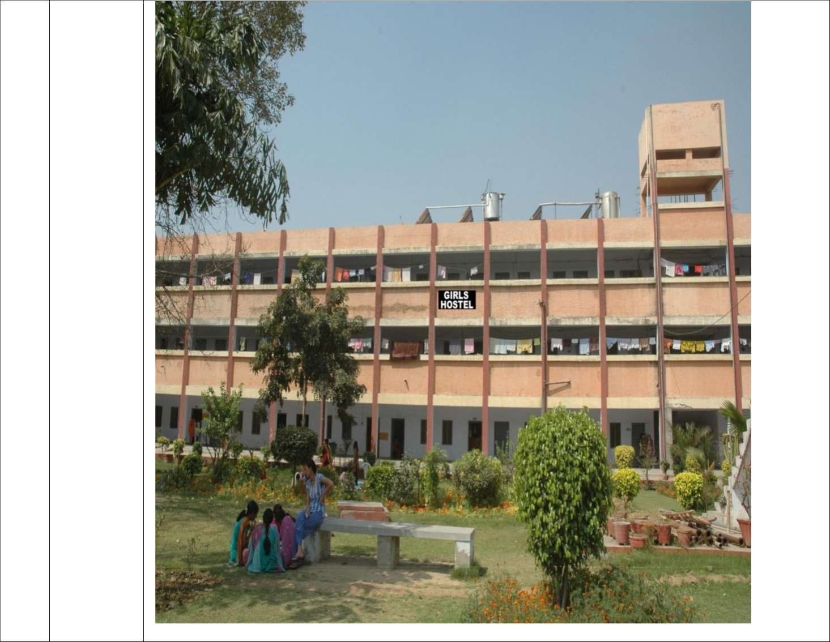
Girls

Hostel

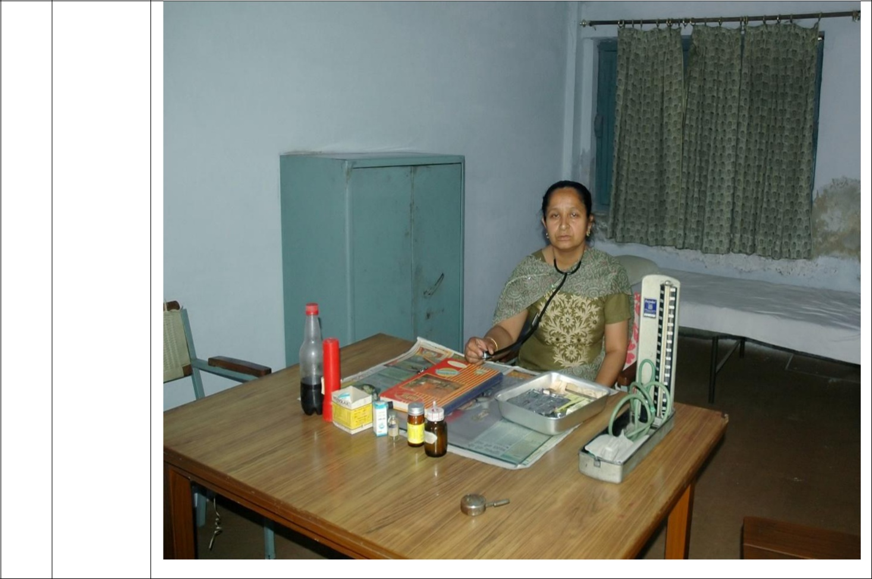
Medical

- other facilities at Hostel

17 | Academic session | JULY – APRIL
 | Examination system | Yearly
 | Period of Declaration of results | JUNE - JULY
18 | Counseling/ Mentoring | Available
 | Career Counseling | Available
 | Student Insurance | Not Available
19 | Students Activity Body | -
 | Cultural Activities | Held Periodically
 | Sports Activities | Athletics, Cricket, Badminton & Indoor Games

 | Library activities | Book Bank Facility, Subscription to Online
 |  | International Journals
 | Magazine/ Newsletter | Available
 | Technical Activities | International Pharmacist day celebration  National Pharmacy Weak Celebrations
 | Industrial Visits/ Tours | Conducted
 | Alumni activities | Alumni meeting arranged.

Annexure I

Annexure-A: Four MEMBER /INDIVIDUAL DETAILS
Details of the Individuals/ members/office bearers of organization
Name of the Members of the Trust / Society / Company |  |  |  | Designation in the Company |  | Qualification |  |  | Experience in running higher educational, technical or other professional institutions (in years)
Mr. Pawan Kumar Gupta |  |  |  | President |  | B.Sc., LLB |  |  | 9
Mr. Raj Kumar Mittal |  |  |  | Vice President |  | Graduate |  |  | 5
Mr. Ashok Kumar |  |  |  | General Secretary |  | Graduate |  |  | 9
Mr. Jai Kanwar jain |  |  |  | Treasurer |  | 10+2 |  |  | 9
NAME AND ADDRESS OF THE MEMBERS OF THE GOVERNING BODY AS PER THE COMPOSITION PRESCRIBED BY AICTE
S. No | Name | Position | Qualification |  | Present Professional position / Occupation |  | Telephone Numbers | E-mail |  | Address
01. | Mr. Brij Lal Garg | Member Managing Committee | B.Com. ,LLB |  | Business |  | 08053676319 | hindueducationsociety@gmail.com |  | H.No. 1233,Sector-15,Sonepat
02. | Mr. Dharam Pal Chhabra | Member Managing Committee | Graduate |  | Business |  | 09416015755 | hindueducationsociety@gmail.com |  | H. No. 215, Sector- 14, Sonepat
03. | Mr. Girish Sharma | Member Managing Committee | Graduate |  | Business |  | 9136066066 | hindueducationsociety@gmail.com |  | D-109,A,Gali No. 1,Burari Road,Sarup Nagar,Delhi-42
04. | Mr. Kushi Ram Gupta | Member Managing Committee | JBT |  | Business |  | 09215515209 | hindueducationsociety@gmail.com |  | M/S Gupta steel ,Kath Mandi,Sonepat
05. | Mr. Pawan Kumar Goyal | Member Managing Committee | Graduate |  | Business |  | 9315333222 | hindueducationsociety@gmail.com |  | M/S Kallu Mal Pawan Kumar,Anaj Mandi Sonipat
06. | Mr. Pawan Kumar Mittal | Member Managing Committee | Graduate |  | Business |  | 9896421482 | hindueducationsociety@gmail.com |  | M/S Pawan Timmar Store ,Kath Mandi,Sonipat
07. | Mr. Rajender Kumar | Member Managing Committee | Graduate |  | Business |  | 0130-2244857 | hindueducationsociety@gmail.com |  | M/S Paras Ram Basesar lal Rohtak Road Sonepat
08. | Mr. Rajender Kumar Goel | Member Managing Committee | Graduate |  | Business |  | 9896042561 | hindueducationsociety@gmail.com |  | H. No.50,Sector-14 Sonepat
09. | Mr. Ram Kumar Mittal | Member Managing Committee | Graduate |  | Business |  | 9211421433 | hindueducationsociety@gmail.com |  | H. No. 1/460 Mission Road Sonepat
10. | Mr. Ravi Parkash | Member Managing Committee | LLB |  | Business |  | 9811395880 | hindueducationsociety@gmail.com |  | H. No.484,Sector-14 Sonepat
11. | Mr. Satish Mohan Bansal | Member Managing Committee | B.A. ,LLB |  | Business |  | 09354630038 | hindueducationsociety@gmail.com |  | H. No.77-L,Model Town,Sonepat
12. | Mr. Sham Lal Jain | Member Managing Committee | Graduate |  | Business |  | 9891627006 | hindueducationsociety@gmail.com |  | H. No. J-97,RBI Enclave Pasham Vihar, New Delhi
13. | Mr. Shri Krishan Gupta | Member Managing Committee | Graduate |  | Business |  | 9255381855 | hindueducationsociety@gmail.com |  | H. No.50 Ward No. 22 Kath Mandi, Near Hindu Vidya Peeth, Sonepat
14. | Mr. Shri Pal Aggarwal | Member Managing Committee | Graduate |  | Business |  | 9312034063 | hindueducationsociety@gmail.com |  | H. No. BA-4 West Shalimar Bagh Delhi-88
15. | Mr. Sunil Khandelwal | Member Managing Committee | Graduate |  | Business |  | 9416012690 | hindueducationsociety@gmail.com |  | H. No.1064,Sector-14 Sonepat
16. | Mr. Surrender Kumar | Member Managing Committee | Graduate |  | Business |  | 9215631300 | hindueducationsociety@gmail.com |  | E-39, Industrial Area Sonepat
17. | Mr. Suresh Kumar | Member Managing Committee | Graduate |  | Business |  | 9812036421 | hindueducationsociety@gmail.com |  | Shop No. 15 Anaj Mandi,Sonipat

Annexure II
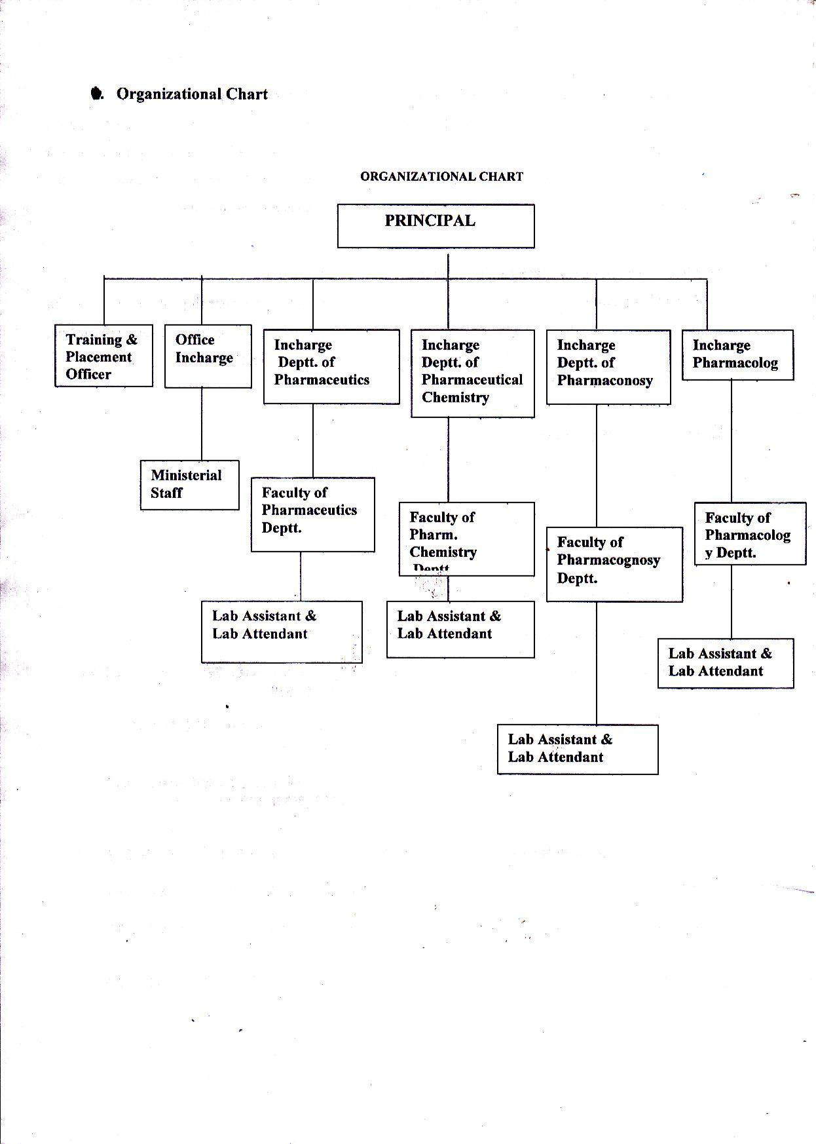

Annexure III
Faculty Details

S.No | Name | Qualification | Department | Aadhar Number
1 | Dr. Bharat Bhushan | M.Pharm , Ph.D | Pharm, Chemistry | 967632305436
2 | Mrs. Jyoti | M.Pharm | Pharmacognosy | 763228838375
3 | Mrs. Preeti Garg | M.Pharm | Pharmacognosy | 911743825075
4 | Miss Shilpa Jain | M.Pharm | Pharm, Chemistry | 498208573834
5 | Mr. Naveen | M.Pharm | Pharmaceutics | 826256976916
6 | Mrs. Garima Mittal | M.Pharm | Pharmacology | 722077462338
7 | Mr. Vineet Vashist | M.Pharm | Pharmaceutics

