HINDU COLLEGE OF PHARMACY SONIPAT, HARYANA MANDATORY DISCLOSURE

(2020-21)

Mandatory Disclosure
 | Date of Mandatory Disclosure | APRIL 2021
 | AICTE File No. | 765-62-203(P)/ET/95
 | Date & Period of Last approval | 10 APRIL 2020; 2020-21
Sr. No. | Particulars |  |  | Data
1 | Name of the Institution | HINDU |  | COLLEGE |  |  |  |  | OF
 |  | PHARMACY
1.1 | Address of the Institution | NEAR |  |  | PANCHAYAT
 |  | BHAWAN, GOHANA ROAD
1.2 | City & Pin Code | SONIPAT – 131001
1.3 | State/ UT | HARYANA
1.4 | Phone number with STD code | 0130-2221072
1.5 | Email | hcpsnp@hry.nic.in
1.6 | Mobile | 9868164558
2 | Name of the Society running institution | The |  | Sonepat |  |  |  |  | Hindu
 |  | Educational |  |  | & |  |  | Charitable
 |  | Society, Sonipat
2.1 | Address of the Society | Hindu |  | Vidya | Peeth, |  |  |  | Senior
 |  | Wing, Kath Mandi, Sonepat
2.2 | Phone number with STD code | 0130-2212960
2.3 | Email | hindueducationsociety@gmail.
 |  | com
2.4 | Mobile | 7678275438
3 | Name of Principal/Director | Dr. (Mrs.) Saroj Jain
3.1 | Address | HINDU |  | COLLEGE |  |  |  |  | OF
 |  | PHARMACY |  |  |  |  |  |  | NEAR
 |  | PANCHAYAT |  |  |  |  | BHAWAN,
 |  | GOHANA ROAD
3.2 | City & Pin Code | SONIPAT – 131001
3.3 | State/ UT | HARYANA
3.4 | Phone number with STD code | 0130-2221072
3.5 | Email | sarojhcp@yahoo.com
3.6 | Mobile | 9868164558
4 | Name of the affiliating Bodies
4.1 | Name of the affiliating Board | Haryana |  | State |  |  | Board of
 |  | Technical Education
4.1.1 | Address | Bays 7-12, Sector- 4,
 |  | Panchkula, Haryana

4.1.2 | Website | www.hsbte.org
4.1.3 | Latest affiliation period | 2019-20
4.2 | Name of the affiliating University | Pt. B.D. Sharma University of
 |  | Health Sciences, Rohtak
4.2.1 | Address | Delhi Road , Rohtak
4.2.2 | Website | www.uhsr.ac.in
4.2.3 | Latest affiliation period | 2020-21

5 | Governess
5.1 | Members of the Governing Body | Annexure -1
5.2 | Members of Academic Advisory Body | Annexure -2
5.3 | Frequently of the Board Meeting and Academic | Twice in a year
 | Advisory Body
5.4 | Organizational chart and processes | Annexure -3
5.5 | Nature and Extent of involvement of Faculty and | Extra | classes arranged | for
 | students in academic affairs/improvements | weaker students
5.6 | Mechanism/ Norms and Procedure for democratic/ | Norms are being followed for
 | good Governance | good Governance
5.7 | Student Feedback on Institutional Governance/ | Student | feedback is | taken
 | Faculty performance | regularly
5.8 | Grievance Redressal mechanism for Faculty, staff | Yes
 | and students
5.9 | Establishment of Anti Ragging Committee | Annexure -4
5.10 | Establishment of Online Grievance Redressal | Yes
 | Mechanism
5.11 | Establishment of Grievance Redressal Committee | Annexure -5
 | in the Institution and Appointment of
 | OMBUDSMAN by the University
5.12 | Establishment of Internal Complaint Committee | Annexure -6
 | (ICC)
5.13 | Establishment of Committee for SC/ ST | Annexure -7
5.14 | Internal Quality Assurance Cell | Annexure -8

6 | Programmes
6.1 | Name of Programmes approved by AICTE | D. Pharmacy
 |  | B.Pharmacy
 |  | M.Pharmacy (Pharmaceutics)
6.2 | Name of Programmes Accrediated by AICTE | N/A
6.3 | Status of Accreditation of the courses | N/A
6.3.1 | Total number of courses | N/A
6.3.2 | No. of Courses for which applied for Accreditation | N/A
6.3.3 | Status of Accreditation – Preliminary/ Applied for SAR | N/A
 | and results awaited/ Applied for SAR
and visits completed/ Results of the visits awaited/ Rejected/ Approved for ….. Courses

6.4 | For each Programme the following details are to be
 | given
6.4.1 | Name
6.4.2 | Number of seats
6.4.3 | Duration
6.4.4 | Cut off marks/rank of admission during last three
 | years
6.4.5 | Fee
6.4.6 | Placement facilities
6.4.7 | Campus placement in last three years with
 | minimum salary, maximum salary and average
6.5 | salary
 | Name and duration of programme(s) having Twinning
 | and Collaboration with Foreign University(s)
 | and being run in the same Campus along with status of
 | their AICTE approval. If there is Foreign
6.5.1 | Collaboration, give the following details:
 | Details of the Foreign University
6.5.1.1 | Name of the University
6.5.1.2 | Address
6.5.1.3 | Website
6.5.1.4 | Accreditation status of the University in its Home
6.5.1.5 | Country
 | Ranking of the University in the Home Country
6.5.1.6 | Whether the degree offered is equivalent to an Indian
 | Degree? If yes, the name of the agency
 | which has approved equivalence. If no, implications for
 | students in terms of pursuit of higher
 | studies in India and abroad and job both within and
6.5.1.7 | outside the country
 | Nature of Collaboration
6.5.1.8 | Conditions of Collaboration
6.5.1.9 | Complete details of payment a student has to make to
6.6 | get the full benefit of Collaboration
 | For each Programme Collaborated provide the
6.6.1 | following:
 | Programme Focus
6.6.2 | Number of seats
6.6.3 | Admission Procedure

D. Pharm., B. Pharm., M. Pharm.

D60, B60, M 9

- 2Yrs, B 4Yrs, M 2Yrs

- CAY49, CAY-1, 47, CAY-2, 45
- CAY50, CAY-1, 52, CAY-2, 50
- CAY62, CAY-1, 60, CAY-2, 62

Annexure 9

Available, Placement cell has been constituted Annexure 10

Annexure 11

N/A

N/A
N/A
N/A
N/A

N/A

N/A
N/A

N/A
N/A
N/A

N/A
N/A
N/A

6.6.4 | Fee | N/A
6.6.5 | Placement Facility | N/A
6.6.6 | Placement Records for last three years with minimum | N/A
6.7 | salary, maximum salary and average salary | N/A
 | Whether the Collaboration Programme is approved by
 | AICTE? If not whether the Domestic/Foreign
 | University has applied to AICTE for approval

7 | Faculty
7.1 | Branch wise list Faculty members
7.1.1 | Permanent Faculty | Annexure 12
7.1.2 | Adjunct Faculty | Annexure 13
7.1.3 | Permanent Faculty: Student Ratio | 1:20
7.2 | Number of Faculty employed and left during the | Left 4, Joined 08
 | last three years

8 | Profile of Vice Chancellor/ Director/
 | Principal/ Faculty
8.1 | Name | Dr.(Mrs.) Saroj Jain
8.2 | Date of Birth | 04/03/1960
8.3 | Unique id | 471441988772
8.4 | Education Qualifications | M. Pharm., Ph.D.
8.5 | Work Experience
8.5.1 | Teaching | 33 Years
8.5.2 | Research | 13 Years
8.5.3 | Industry | Nil
8.6 | Area of Specialization | Pharmaceutics
8.7 | Courses taught at Diploma/ Post Diploma/ Under | Pharmaceutics
 | Graduate/ Post Graduate/ Post Graduate
 | Diploma Level
8.8 | Research guidance
8.8.1 | No. of papers published in National/ International | 25 | National
 | Journals/ Conferences | 05 | International
8.8.2 | Master | 26 | Students
8.8.3 | Ph.D. | 01
8.9 | Projects Carried out | Nil
8.10 | Patents | Nil
8.11 | Technology Transfer | Nil
8.12 | Research Publications | 15
8.13 | No. of Books published with details | Nil

- Fee

9.1 | Details of fee, as approved by State Fee Committee, | Annexure 9
 | for the Institution
9.2 | Time schedule for payment of fee for the entire | August, December

 | programme
9.3 | No. of Fee waivers granted with amount and name | Nil
 | of students
9.4 | Number of scholarship offered by the Institution, | Nil
 | duration and amount
9.5 | Criteria for fee waivers/scholarship | Nil
9.6 | Estimated cost of Boarding and Lodging in Hostels | Nil

10 | Admission
10.1 | Number of seats sanctioned with the year of | Annexure 14
 | approval
10.2 | Number of Students admitted under various | Annexure 15
 | categories each year in the last three years
10.3 | Number of applications received during last two | DCAY45 | DCAY-1, | 40
 | years for admission under Management Quota and | BCAY48 | BCAY-1, 42
 | number admitted | MCAY15 | MCAY-1, | 12

11 Admission Procedure
11.1 Mention the admission test being followed, name and address of the Test Agency and its URL (website)

11.2 Number of seats allotted to different Test Qualified candidate separately (AIEEE/ CET (State conducted test/ University tests/ CMAT/ GPAT)/ Association conducted test)

11.3 Calendar for admission against Management/vacant seats
11.3.1 Last date of request for applications
11.3.2 Last date of submission of applications
11.3.3 Dates for announcing final results

11.3.4 Release of admission list (main list and waiting list shall be announced on the same day)

11.3.5 Date for acceptance by the candidate (time given shall in no case be less than 15 days)
11.3.6 Last date for closing of admission
11.3.7 Starting of the Academic session

11.3.8 The waiting list shall be activated only on the expiry of date of main list

11.3.9 The policy of refund of the fee, in case of withdrawal, shall be clearly notified

Through HSBTE (Diploma)

Preference given to GPAT Qualified candidates for admission in M. Pharmacy

M-24/7/20, B-14/7/20, D-13/7/20

M-30/7/20, B-21/7/20 D-18/7/20

M-14/8/20, B-14/8/20, D-
21/7/20

31/12/20

NA

30 December D & B December 2020 , M- Novemver 2020
NA
Yes

12 | Criteria and Weightages for Admission
12.1 | Describe each criterion with its respective | Merit prepared based on Marks
 | weightages i.e. Admission Test, marks in qualifying | in qualifying examination
 | examination etc.
12.2 | Mention the minimum level of acceptance, if any | NLT 45%
12.3 | Mention the cut-off levels of percentage and | N/A
 | percentile score of the candidates in the admission
 | test for the last three years
12.4 | Display marks scored in Test etc. and in aggregate | N/A
 | for all candidates who were admitted

13 List of Applicants
13.1 List of candidate whose applications have been Annexure 16 received along with percentile/percentage score for
each of the qualifying examination in separate categories for open seats. List of candidate who have applied along with percentage and percentile score for Management quota seats

14 | Results of Admission Under Management
 | seats/Vacant seats
14.1 | Composition of selection team for admission under | Annexure 17
 | Management Quota with the brief profile of
 | members (This information be made available in
 | the public domain after the admission process is
 | over)
14.2 | Score of the individual candidate admitted arranged | Annexure 18
 | in order or merit
14.3 | List of candidate who have been offered admission | Annexure 18
14.4 | Waiting list of the candidate in order of merit to be | NA
 | operative from the last date of joining of the first
 | list candidate
14.5 | List of the candidate who joined within the date, | Annexure 18
 | vacancy position in each category before operation
 | of waiting list

15 | Information of Infrastructure and Other
 | Resources Available
15.1 | Number of Class Rooms and size of each | 4*75 | Sq. meter
15.2 | Number of Tutorial rooms and size of each | 4*33 | Sq. meter
15.3 | Number of Laboratories and size of each | 14*75 Sq. meter
15.4 | Number of Drawing Halls with capacity of each | NA
15.5 | Number of Computer Centres with capacity of each | 1*75 | Sq. meter
15.6 | Central Examination Facility, Number of rooms | 1*30 | Sq. meter, 6*75 Sq. meter
 | and capacity of each

15.7 | Barrier Free Built Environment for disabled and | Yes
 | elderly persons
15.8 | Occupancy Certificate | Annexure 19
15.9 | Fire and Safety Certificate | Annexure 20
15.10 | Hostel Facilities | Yes
15.11 | Library | 2*150 Sq. meter
15.11.1 | Number of Library books/ Titles/ Journals available | Annexure 21
 | (program-wise)
15.11.2 | List of online National/ International Journals | DELNET Subscription
 | subscribed
15.11.3 | E- Library facilities | Yes
15.12 | Laboratory and Workshop | Yes
15.12.1 | List of Major Equipment/Facilities in each | Annexure 22
 | Laboratory/ Workshop
15.12.2 | List of Experimental Setup in each Laboratory/ | Available
 | Workshop
15.13 | Computing Facilities
15.13.1 | Internet Bandwidth | 32Mbps
15.13.2 | Number and configuration of System | 56 with latest configuration
15.13.3 | Total number of system connected by LAN | 40
15.13.4 | Total number of system connected by WAN | 40
15.13.5 | Major software packages available | Yes
15.13.6 | Special purpose facilities available | Animal | experimentation
 |  | software available
15.14 | Innovation Cell | Annexure 23
15.15 | Social Media Cell | Annexure 24
15.16 | Compliance of the National Academic Depository | N/A
 | (NAD), applicable to PGCM/ PGDM Institutions
 | and University Departments
15.17 | List of facilities available
15.17.1 | Games and Sports Facilities | Available
15.17.2 | Extra-Curricular Activities | Yes
15.17.3 | Soft Skill Development Facilities | Yes
15.18 | Teaching Learning Process | Participated
15.18.1 | Curricula and syllabus for each of the programmes | Followed
 | as approved by the University
15.18.2 | Academic Calendar of the University | Follow
15.18.3 | Academic Time Table with the name of the Faculty | Annexure 25
 | members handling the Course
15.18.4 | Teaching Load of each Faculty | Annexure 26
15.18.5 | Internal Continuous Evaluation System and place | Yes
15.18.6 | Student’s assessment of Faculty, System in place | Yes
15.19 | For each Post Graduate Courses give the following:
15.19.1 | Title of the Course | M. Pharmacy (Pharmaceutics)

15.19.2 | Curricula and Syllabi | As per Pt. B.D. Sharma
 |  | University of Health Sciences,
 |  | Rohtak
15.19.3 | Laboratory facilities exclusive to the Post Graduate | Yes
 | Course
15.20 | Special Purpose
15.20.1 | Software, all design tools in case | Available
15.20.2 | Academic Calendar and frame work | Followed
16 | Enrollment of students in the last 3 years | Annexure 27
17 | List of Research Projects/ Consultancy
 | Works
17.1 | Number of Projects carried out, funding agency, | Nil
 | Grant received
17.2 | Publications (if any) out of research in last three | 05
 | years out of masters projects
17.3 | Industry Linkage | Yes
17.4 | MoUs with Industries (minimum 3) | Annexure 28
18 | LoA and subsequent EoA till the current | Annexure 29
 | Academic Year
19 | Accounted audited statement for the last | Annexure 30
 | three years
20 | Best Practices adopted, if any | Yes

Annexures

Annexure I

Annexure-A: Four MEMBER /INDIVIDUAL DETAILS
Details of the Individuals/ members/office bearers of organization
Name of the Members of the Trust / Society / Company |  |  |  | Designation in the Society |  | Qualification |  |  | Experience in running higher educational, technical or other professional institutions (in years)
Mr. Pawan Kumar Gupta |  |  |  | President |  | B.Sc., LLB |  |  | 10
Mr. Raj Kumar Mittal |  |  |  | Vice President |  | Graduate |  |  | 6
Mr. Ashok Kumar |  |  |  | General Secretary |  | Graduate |  |  | 10
Mr. Jai Kanwar jain |  |  |  | Treasurer |  | 10+2 |  |  | 10
NAME AND ADDRESS OF THE MEMBERS OF THE GOVERNING BODY AS PER THE COMPOSITION PRESCRIBED BY AICTE
S. No | Name | Position | Qualification |  | Present Professional position / Occupation |  | Telephone Numbers | E-mail |  | Address
01. | Mr. Brij Lal Garg | Member Managing Committee | B.Com. ,LLB |  | Business |  | 08053676319 | hindueducationsociety@gmail.com |  | H.No. 1233,Sector-15,Sonepat
02. | Mr. Dharam Pal Chhabra | Member Managing Committee | Graduate |  | Business |  | 09416015755 | hindueducationsociety@gmail.com |  | H. No. 215, Sector- 14, Sonepat
03. | Mr. Girish Sharma | Member Managing Committee | Graduate |  | Business |  | 9136066066 | hindueducationsociety@gmail.com |  | D-109,A,Gali No. 1,Burari Road,Sarup Nagar,Delhi-42
04. | Mr. Kushi Ram Gupta | Member Managing Committee | JBT |  | Business |  | 09215515209 | hindueducationsociety@gmail.com |  | M/S Gupta steel ,Kath Mandi,Sonepat
05. | Mr. Pawan Kumar Goyal | Member Managing Committee | Graduate |  | Business |  | 9315333222 | hindueducationsociety@gmail.com |  | M/S Kallu Mal Pawan Kumar,Anaj Mandi Sonipat
06. | Mr. Pawan Kumar Mittal | Member Managing Committee | Graduate |  | Business |  | 9896421482 | hindueducationsociety@gmail.com |  | M/S Pawan Timmar Store ,Kath Mandi,Sonipat
07. | Mr. Rajender Kumar | Member Managing Committee | Graduate |  | Business |  | 0130-2244857 | hindueducationsociety@gmail.com |  | M/S Paras Ram Basesar lal Rohtak Road Sonepat
08. | Mr. Rajender Kumar Goel | Member Managing Committee | Graduate |  | Business |  | 9896042561 | hindueducationsociety@gmail.com |  | H. No.50,Sector-14 Sonepat
09. | Mr. Ram Kumar Mittal | Member Managing Committee | Graduate |  | Business |  | 9211421433 | hindueducationsociety@gmail.com |  | H. No. 1/460 Mission Road Sonepat
10. | Mr. Ravi Parkash | Member Managing Committee | LLB |  | Business |  | 9811395880 | hindueducationsociety@gmail.com |  | H. No.484,Sector-14 Sonepat
11. | Mr. Satish Mohan Bansal | Member Managing Committee | B.A. ,LLB |  | Business |  | 09354630038 | hindueducationsociety@gmail.com |  | H. No.77-L,Model Town,Sonepat
12. | Mr. Sham Lal Jain | Member Managing Committee | Graduate |  | Business |  | 9891627006 | hindueducationsociety@gmail.com |  | H. No. J-97,RBI Enclave Pasham Vihar, New Delhi
13. | Mr. Shri Krishan Gupta | Member Managing Committee | Graduate |  | Business |  | 9255381855 | hindueducationsociety@gmail.com |  | H. No.50 Ward No. 22 Kath Mandi, Near Hindu Vidya Peeth, Sonepat
14. | Mr. Shri Pal Aggarwal | Member Managing Committee | Graduate |  | Business |  | 9312034063 | hindueducationsociety@gmail.com |  | H. No. BA-4 West Shalimar Bagh Delhi-88
15. | Mr. Sunil Khandelwal | Member Managing Committee | Graduate |  | Business |  | 9416012690 | hindueducationsociety@gmail.com |  | H. No.1064,Sector-14 Sonepat
16. | Mr. Surrender Kumar | Member Managing Committee | Graduate |  | Business |  | 9215631300 | hindueducationsociety@gmail.com |  | E-39, Industrial Area Sonepat
17. | Mr. Suresh Kumar | Member Managing Committee | Graduate |  | Business |  | 9812036421 | hindueducationsociety@gmail.com |  | Shop No. 15 Anaj Mandi,Sonipat

Annexure II

Details of Academic Advisory Body

S.No | Name of Members | Designation | Qualification | Experiences (Years)
1 | Dr. Satish Sardana | Director, Amity University, Manesar, Gurugram | M. Pharm, Ph. D | 40
2 | Dr. Jitender Madan | Associate Professor, Niper, Hyderabad | M.Pharm,  Ph. D,  Post Doct. | 19
3 | Dr. Veena Garg | Principal, BPMV Institute of Higher Learning | Ph. D | 25

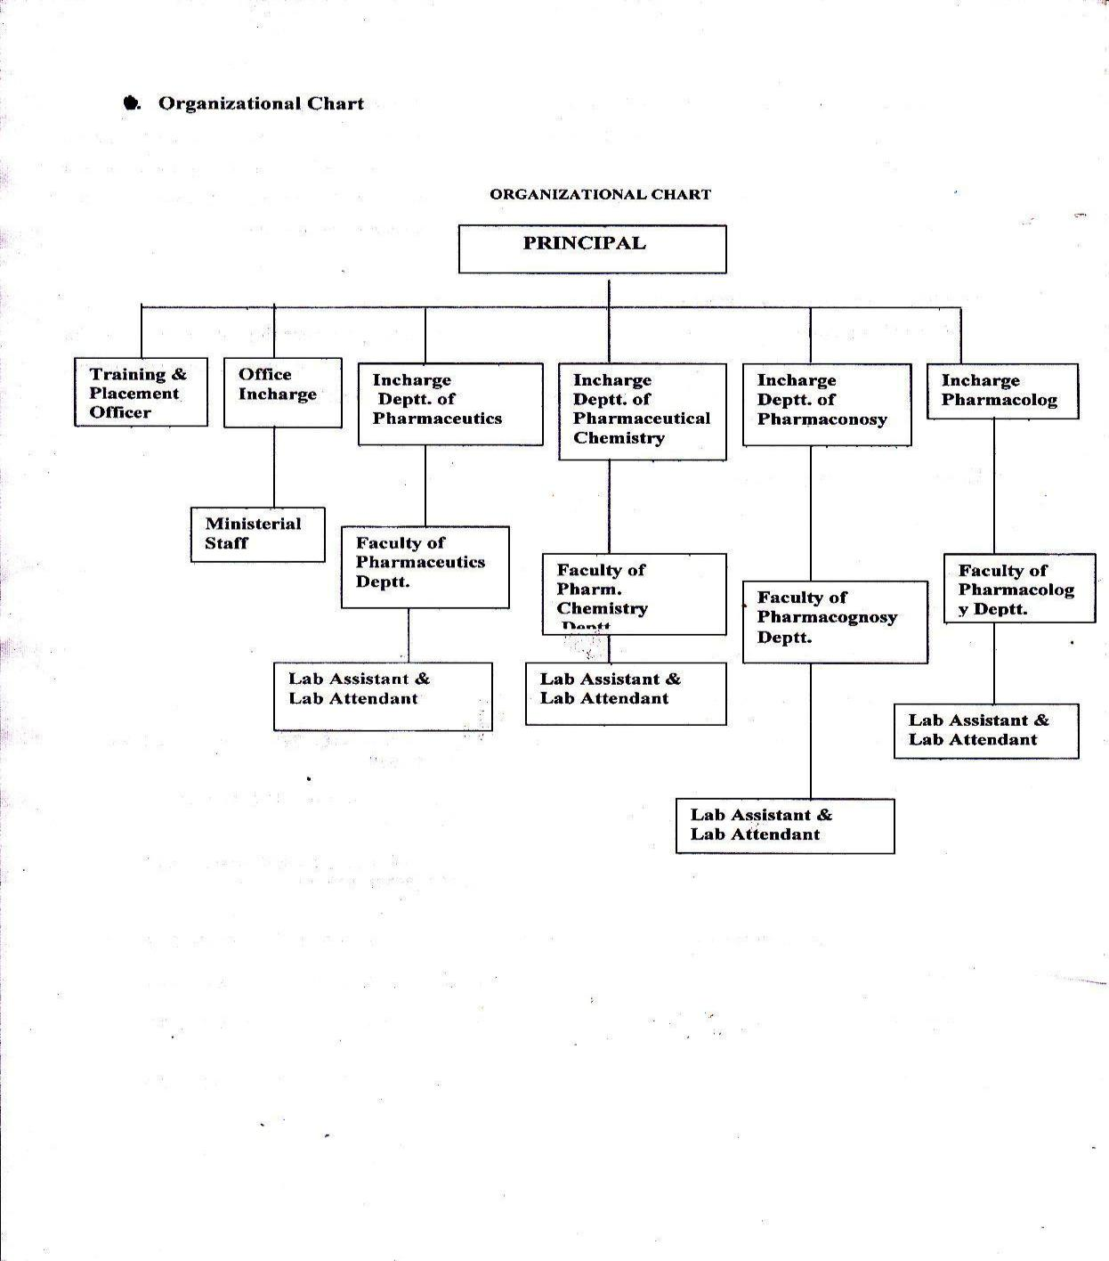
Annexure III

Annexure IV
ANTI-RAGGING COMMITTEE

NAME AND ADDRESS OF THE MEMBERS OF THE ANTI-RAGGING COMMITTEE
S.No | Name | Position | Qualification | Present Professional position / Occupation | Telephone Numbers | E-mail | Address
01. | Dr. Saroj Jain | Chairperson | M. Pharm. Ph.D. | Principal | 9868164558 | sarojhcp@yahoo.com | E-50, iind floor, Sector-1, Rohini,Delhi-110085
02. | Dr. Manju Kamra | Member | M. Pharm.  Ph.D | Associate Professor | 9868245879 | kamramanju@yahoo.com | SU-147, Pitam Pura, Delhi
03. | Dr. Bharat Bhushan | Member | M. Pharm.  Ph.D | Associate Professor | 9416179732 | bbhushanpharma@gmail.com | 623/21, Narender Nagar, Sonepat,Haryana
04. | Dr. Rahul Sharma | Member | M. Pharm.  Ph.D | Associate Professor | 9416494677 | rahulpharmacy13@gmail.com | 264, Sector 15, Sonipat
05. | Mr. Sangeet Kumar | Member | M. Pharm. | Assistant Professor | 9813033239 | Sharmasangeet1489@gmail.com | 373, Bayanpur Khurd, Rathdana Road Sonipat

Annexure V

GRIEVANCE REDRESSAL COMMITTEE

NAME AND ADDRESS OF THE MEMBERS OF THE GRIEVANCE REDRESSAL COMMITTEE
S.No | Name | Position | Qualification | Present Professional position / Occupation | Telephone Numbers | E-mail | Address
01. | Dr. Saroj Jain | Chairperson | M. Pharm. Ph. D. | Principal | 9868164558 | sarojhcp@yahoo.com | E-50,IInd floor,Sector-1,Rohini,Delhi
02. | Dr.Manju kamra | Member | M.Pharm Ph.D | Associate Professor | 9868245879 | kamramanju@yahoo.com | Delhi
03. | Dr. Bharat Bhushan | Member | M. Pharm.  Ph.D | Associate Professor | 9416179732 | bbhushanpharma@gmail.com | 623/21, Narender Nagar, Sonepat,Haryana
04. | Mr. Suraj Pal | Member | M.A, D. Lib | Librarian | 9416693212 | hcpsnp@hry.nic.in | Sonipat
05. | Mrs. Shilpa | Member | MA B LIB | Clerk | 8950257914 | hcpsnp@hry.nic.in | Sonipat
06. | Ms. Prachi Nagpal | Student | B.Pharmacy | Student | 9518855179 | Prachinagapal050399@gmail.com | Sonipat
07. | Mr. Akshay | Student | B. Pharmacy | Student | 9911446515 | Akshayhooda57@gmail.com | Sonipat

Annexure VI
Internal Complaint Committee

NAME AND ADDRESS OF THE MEMBERS OF THE INTERNAL COMPLAINT COMMITTEE
S.No | Name | Position | Qualification | Present Professional position / Occupation | Telephone Numbers | E-mail | Address
01. | Dr. Saroj Jain | Chairperson | M. Pharm. Ph. D. | Principal | 9868164558 | sarojhcp@yahoo.com | E-50,IInd floor,Sector1,Rohini,Delhi
02. | Mr. Sunil Kumar Batra | Chairperson | M. Pharm. | Associate Professor | 9868300648 | sunilkbatra@yahoo.co.in | A-27,Batra Bhawan,New Gupta Colony,Delhi
03. | Dr. Arun Mittal | Member | M. Pharm.  Ph.D | Associate Professor | 9354806431 | Mittalarun07@rediffmail.com | 152/21, Panhsheel Colony,Sonepat,Haryana
04. | Dr. Seema Rohilla | Member | M. Pharm.  Ph. D | Assistant Professor | 9671007907 | Seemarohilla9@gmail.com | 285/11, Adarsh Nagar, Sonepat
05. | Mrs. Jyoti | Member | M. Pharm. | Assistant Professor | 9896459487 | jyoti.sumit19@gmail.com | C-4, Pancham nagar, Sonipat

Annexure VII

Discrimination Committee against SC/ST/OBC

NAME AND ADDRESS OF THE MEMBERS OF THE COMMITTEE FOR SC/ST/OBC
S.No | Name | Position | Qualification | Present Professional position / Occupation | Telephone Numbers | E-mail | Address
01. | Dr. Saroj Jain | Chairperson | M. Pharm. Ph. D. | Principal | 9868164558 | sarojhcp@yahoo.com | E-50,IInd floor,Sector-1,Rohini,Delhi
02. | Dr. Arun Mittal | Member | M. Pharm.  Ph.D | Associate Professor | 9354806431 | Mittalarun07@rediffmail.com | 152/21, Panhsheel Colony,Sonepat,Haryana
03. | Dr.(Mrs.) Seema Rohilla | Member | M. Pharm. Ph.D | Assistant Professor | 9671007907 | Seemarohilla9@gmail.com | 285/11, Adarsh Nagar, Sonepat
04. | Mrs. Jyoti | Member | M. Pharm. | Assistant Professor | 9896459487 | Jyoti.sumit19@gmail.com | 165, Opp. Irrigation Office , Rathdhana Road, Sonipat

]

Annexure VIII
Internal quality Assurance cell

S.No | Name | Position | Qualification | Present Position/Qualification | Phone No. | E mail
01. | Dr. Saroj Jain | Chairperson | M. Pharm. Ph. D. | Principal | 9868164558 | sarojhcp@yahoo.com
02 | Sh. Sunil Kumar Batra | Memebr | M. Pharm | Associate Professor | 9868300648 | sunilkbatra@yahoo.com
03 | Sh. Vishnu Dutt | Member | M.C.A | Assistant Professor | 9466767914 | Bhardwaj22_sonu@yahoo.com
04 | Mrs. Jyoti | Member | M. Pharm | Assistant Professor | 9896459487 | jyoti.sumit19@gmail.com

 |  | Annexure IX
 |  | Fee Detail
Fee Detail for D. Pharm. Programme
S.No | Fee Name |  | Amount
1 | Admission Fee | 200
2 | Tuition Fee | 22,000
3 | Development Fund | 5,000
4 | Boys Fund | 1,200
5 | H.S.B.T.E. Exam Fee | 250
5 | Security (Refundable) | 1,500
Total |  | 30,150
Fee Detail for B. Pharm. Programme
S.No | Fee Name |  | Amount
1 | Admission Fee | 200
2 | Tuition Fee | 40,000
3 | Development Fund | 10,000
4 | Boys Fund | 1,500
5 | University dues | 6750
5 | Security (Refundable) | 2,000
Total |  | 60,450
Fee Detail for M. Pharm. Programme
S.No | Fee Name |  | Amount
1 | Admission Fee | 1,000
2 | Tuition Fee | 75,000
3 | Development Fund | 25,000
4 | Boys Fund | 1,500
5 | University dues | 8750
Total |  | 1,11,250

S.No | Name | Position | Qualification | Present Position/Qualification | Phone No. | E mail
01. | Dr. Saroj Jain | Chairperson | M. Pharm. Ph. D. | Principal | 9868164558 | sarojhcp@yahoo.com
02 | Sh. Sunil Kumar Batra | Memebr | M. Pharm | Associate Professor | 9868300648 | sunilkbatra@yahoo.com
03 | Dr. Rahul Sharma | Member | M. Pharm  Ph.D | Associate Professor | 9416494667 | Rahulpharmacy13@gmail.com

Annexure X
Placement Cell

 |  |  | Annexure XI
 |  | Placement Record
Year | No. of | Minimum |  | Maximum |  | Average
 | Students | salary |  | salary |  | salary
2017-18 | 47 | 8000 |  | 25000 |  | 15600
2018-19 | 49 | 10000 |  | 26000 |  | 16600
2019-20 | 53 | 10000 |  | 30000 |  | 16000

Annexure XII

List of Permanent Faculty

S.No | Name | Qualification | Designation | Department | Experience | Aadhar Number
1. | Dr. Saroj Jain | M. Pharm, Ph. D | Principal | Pharmaceutics | 32 | 471441988772
2 | Sh. S.K.Batra | M. Pharm | Associate Professor | Pharmaceutics | 31 | 436785960256
3 | Dr. Manju Kamra | M.Pharm  Ph.D | Associate Professor | Pharma chemistry | 30 | 707759676351
4 | Dr. Dinesh Kaushik | M. Pharm, Ph. D | Associate Professor | Pharmaceutics | 25 | 836300045427
5 | Dr. Bharat Bhushan | M. Pharm, Ph. D | Associate Professor | Pharma chemistry | 16 | 967632305436
6 | Dr. Rahul Sharma | M. Pharm  Ph.D | Associate Professor | Pharmaceutics | 14 | 228469299339
7 | Dr. Arun Mittal | M. Pharm, Ph. D | Associate Professor | Pharmacognosy & Phythochemistry | 15 | 642683550715
8 | Dr. Seema Rohilla | M. Pharm, Ph. D | Assistant Professor | Pharmaceutics | 9 | 204668986129
9 | Mrs. Preeti Garg | M. Pharm | Assistant Professor | Pharmacognosy | 7 | 911743825075
10 | Miss Shilpa Jain | M. Pharm | Assistant Professor | Pharma Chemistry | 5 | 498208573834
11 | Sh. Sangeet Kumar Sharma | M. Pharm | Assistant Professor | Pharmaceutics | 5 | 580388507237
12 | Sh. Vishnu Dutt | M.C.A | Assistant Professor | Computer Science | 12 | 891690296261
13 | Mrs. Jyoti | M. Pharm | Assistant Professor | Pharmacognosy & Phythochemistry | 9 | 763228838375
14 | Sh Naveen | M. Pharm | Assistant Professor | Pharmaceutics | 3 | 826256976916
15 | Sh. Vineet Vashisth | M. Pharm | Assistant Professor | Pharmaceutics | 1 | 784543714607
16 | Sh. Birender Singh | M. Pharm | Assistant Professor | Pharma Chemistry | 6 | 672605629486
17 | Miss Reetu Rani | M. Pharm | Assistant Professor | Pharmaceutics | 1 | 366088909797
18 | Miss Tanya Gupta | M. Pharm | Assistant Professor | Pharma Chemistry | 1 | 719398801320
19 | Mrs. Sakshi Garg | M.Pharm | Assistant Professor | Pharmaceutics | 1 | 769524257048
20 | Ms. Jasmine Batra | M.Pharm | Assistant Professor | Pharmacology | 1 | 590832787272
21 | Mr. Tarun Kumar | M.Pharm | Assistant Professor | Pharmacology | 1 | 91174382507

Annexure XIII
List of Adjunct Faculty
S.No | Name | Qualification | Designation | Department | Experience | Aadhar Number
1. | Sh. Amit Kaushik | M. Pharm | Assistant Professor | Pharmaveutics | 02Month | 648973497214
2 | Sh. Kapil Sharma | B. Pharm. | Assistant Professor | Pharmacognosy | 01 Month | 520457800860
3 | Sh. Sunil Jain | M. Pharm. | Assistant Professor | Pharmaceutics | 02 Month | 672404955559
4 | Sh. Sangeet Tiwari | B. Pharm., | Assistant Professor | Pharmaceutics | 02 Month | 959859712142
5 | Mr. Rajesh Verma | M. Pharm | Assistant Professor | Pharmacognosy | 02 months

Annexure XIV
Seat sanctioned with year of approval

S.No. | Course | Approved | Year | of
 |  | Intake | approval
1 | Diploma in Pharmacy | 60 | 1978
2 | Bachelor in Pharmacy | 60 | 1995
3 | Master in Pharmacy (Pharmaceutics) | 09 | 2015

Annexure XV
Number of students admitted under various categories

Course | 2018-19 |  |  | 2019-20 |  |  | 2020-21
 | General | SC/ | OBC/ | General | SC/ST | OBC/ | General | SC/ | OBC/
 |  | ST | BC |  |  | BC |  | ST | BC
D. Pharm. | 47 | 4 | 9 | 42 | 8 | 10 | 43 | 7 | 10
B. Pharm | 44 | 05 | 11 | 48 | 02 | 10 | 44 | 8 | 8
M.Pharm | 9 | - | - | 7 | - | 1 | 8 | 0 | 1

Annexure XVI

Number of students whose applications received under various categories

Course | No. of |  | Open |  |  | Management
 | students | Gen. | SC/ST | BC/OBC | Gen. | SC/ST | BC/OBC
D.Pharm | 112 | 54 | 10 | 10 | 26 | 5 | 7
B.Pharm | 146 | 80 | 7 | 10 | 40 | 5 | 4
M.Pharm | 17 | 14 | 1 | 2 | - | - | -

Annexure XVII
Admission Selection committee under Management Quota

S.No | Name | Position | Qualification | Present Position/Qualification | Phone No. | E mail
01 | Sh. Pawan Kumar Gupta | Chairperman | B.A, L.L.B | Chairman | 01302212960 | hindueducationsociety@gmail.com
02. | Dr. Saroj Jain | Chairperson | M. Pharm., Ph. D. | Principal | 9868164558 | sarojhcp@yahoo.com
03 | Dr. Arun Mittal | Memebr | M. Pharm  Ph.D | Associate Professor | 9354806431 | mittalarun07@rediffmail.com
04 | Sh. Vishnu Dutt | Member | M.C.A | Assistant Professor | 9466767914 | bhardwaj22_sonu@yahoo.com
05 | Mrs. Jyoti | Member | M. Pharm | Assistant Professor | 9896459487 | jyoti.sumit19@gmail.com

Annexure XVIII
List of admitted candidates under various courses

D.Pharmacy

HINDU COLLEGE OF PHARMACY, SONEPAT
D.PHARMACY 1ST YEAR STUDENTS LIST 2020-21

S.NO | NAME | F’NAME | D.O.B | CATEGORY | CONTACT NO. | Marks %
List of candidates admitted through Centralized counseling
 | ANKIT | BAJRANG | 15/07/2003 | BC-A | 9991837637 | 66.80
 | ANKIT BHARDWAJ | SUNIL KUMAR | 11/06/2002 | HOGC | 8307125211 | 84
 | ANKUSH | SAHAB SINGH | 28/01/2003 | BC-A | 9518063670 | 69.75
 | ANURAG | SURENDER KUMAR | 09/09/1999 | SC | 9350539430 | 54.75
 | ARVIND KUMAR | SUNIL | 15/04/2002 | HOGC | 9991656086 | 81.00
 | DEEPAK | ANIL | 03/03/2002 | SC | 9034242904 | 57.25
 | DEEPANSHI | SUBHASH CHANDER | 01/11/2002 | BC-A | 8708917946 | 60.20
 | DIKSHIT | JAGBIR SINGH | 2/10/2001 | HOGC | 7988787056 | 83.75
 | HIMANSH | RAJNISH | 01/05/2002 | BC-A | 9813543984 | 86
 | HIMANSHU | RAJESH | 05/10/2002 | HOGC | 9812688248 | 70.50
 | KARTEEK KAUSHIK | DEEPAK KUMAR  KAUSHIK | 05/05/2004 | HOGC | 9671761214 | 74.20
 | KARTIK BHARDWAJ | SATISH KUMAR | 31/12/2001 | HOGC | 9813379298 | 72.50
 | MOHIT | DEEPAK | 30/07/1995 | HOGC | 7015904113 | 80.00
 | NAVEEN | RAJENDER | 08/04/1996 | HOGC | 8396982837 | 72.25
 | NEHA KAUSHIK | VIJAY KAUSHIK | 10/01/1998 | HOGC | 8307956078 | 78.60
 | NUPUR | RAJ KUMAR | 28/03/1998 | HOGC |  | 75.50
 | PARVESH | NARESH KUMAR | 22/07/2002 | BC-B | 9306727980 | 61.75
 | RINKU | BAJRANG | 27/05/2001 | BC-B | 9466991726 | 65.75
 | RINKU | DALBIR | 19/8/2001 | BC-A | 8307521402 | 70.20
 | ROHAN KUMAR | ISHWAR SINGH | 21/08/2002 | HOGC | 9485801015 | 73
 | ROHAN KUMAR | PRADEEP KUMAR | 03/08/2001 | HOGC | 9034473732 | 78
 | ROHIT | RAJESH | 26/07/2002 | BC-B | 8950102501 | 74.80
 | SACHIN KATARIA | GULAB SINGH | 08/11/1997 | BC-A | 8684990063 | 79.60
 | SAGAR | SUNIL DUTT | 16/10/2002 | HOGC | 8307121661 | 71.25
 | SHANKAR | SURENDER | 04/10/2002 | SC | 9050138627 | 61.50
 | SUMIT | NARESH KUMAR | 13/12/1997 | SC | 8199049597 | 66
 | SUSHIL KUMAR | RAMESHWAR | 10/09/1995 | BC-A | 8529086181 | 70
 | VIJAY PRAJAPAT | JAI BAGHWAN | 07/05/2002 | BC-A | 9050468300 | 81.40
 | VIKAS | SHIVNARAYANA | 4/2/2001 | BC-A | 9817194266 | 66.40
 | VINAY KAUSHIK | JAIPAL | 01/07/2002 | HOGC | 7082535526 | 79
 | VISHAL | BHARAT BHUSHAN | 03/05/2003 | BC-B | 9812138414 | 65.75
 | VISHAL | SATBIR SINGH | 10/09/1999 | SC | 9416105444 | 66
List of candidates admitted through institute level counseling (Left over seats)
 | AJAY KUMAR | SAJJAN KUMAR | 10/08/2002 | BC-A | 9115561965 | 81.0
 | ANIRUDH | RAKESH KUMAR | 07/07/2004 | GENERAL | 8445702581 | 57.4
 | REKHA | RANDHIR | 04/11/1995 | OBC | 8006326263 | 55.40
 | RISHIKA PRASHAR | RAJESH | 21/05/2002 | HOGC | 9729062572 | 61.4
 | SAGAR | JAI BAGHWAN | 04/10/2002 | HOGC | 8199032119 | 60.20
 | SAGAR | AJAY KUMAR | 14/06/1996 | HOGC | 9416485204 | 96
 | SAKSHI | BIJENDER SINGH | 02/03/2000 | HOGC | 9350649928 | 75
 | SHIVAM KHERA | ASHOK KHERA | 11/05/1999 | HOGC | 7988756527 | 62.40
 | SUNNY SINGLA | JAI NARAIN | 04/11/1992 | HOGC | 7988529677 | 69.8
 | VAIBHAV | PARVEEN | 07/10/2002 | HOGC | 8059248921 | 51
 | VANSH | JYOTI SHARMA | 23/10/2001 | HOGC | 9255234299 | 62.20
 | VIKAS | CHETU PARSAD | 31/08/1989 | SC | 8168147144 | 56.40
 | VIKAS DAHIYA | KRISHAN KUMAR | 24/05/1992 | HOGC | 7738801253 | 58.20
List of candidates admitted through institute level counseling ( Management seats)
 | AMAN YADAV | ASHWANI YADAV | 28/08/2000 | OBC | 8168147144 | 76.20
 | AMIT KUMAR | BIJENDER SINGH | 11/07/1999 | OBC | 9306979151 | 71
 | ARUN SAINI | JAI KUMAR | 09/06/2002 | BC-B | 8307360473 | 66
 | BHARTI | KULDEEP SINGH | 28/08/2001 | HOGC | 8607737999 | 72.00
 | DEEPAK | SUSHIL KUMAR | 21/08/2001 | OBC | 9991243303 | 80.20
 | HIMANSHU | RAJU PANDIT | 25/10/2001 | HOGC | 7056207848 | 72.60
 | KHAMOSH | RAJ KUMAR | 06/05/2000 | HOGC | 8295069590 | 59.20
 | MOSSEN | YAMEEN | 10/03/1998 | OBC | 8445235457 | 68.40
 | NAMAN KANSAL | SUSHIL KANSAL | 11/04/2001 | HOGC | 9810466898 | 75
 | NAVED ALI | SAKEEL | 26/06/2000 | OBC | 8168354219 | 64.6
 | NITIN | RAM SANJIVAN | 18/08/2001 | OBC | 7838168383 | 77.60
 | PARAMJEET | ANAND KUMAR | 11/09/2000 | HOGC | 9896957323 | 67.8
 | PAWAN KUMAR | RAJ SINGH | 13/02/1999 | BC-B | 7404323105 | 79.80
 | PRINCE | DARA SINGH | 01/01/2002 | BC-B | 8571840115 | 67.6
 | SHIVANI | ROSHAN LAL | 09/07/2002 | OBC | 8800543595 | 72
List of candidates admitted through institute level counseling (EWS)
 | BHUPENDER | JAIHIND | 17/01/1999 | General | 9211812772 | 64.4%
List of candidates admitted through institute level counseling (TFW)
 | ALEEM | AZAD | 28/12/1999 | BC | 9466582727 | 56.2
 | ANKIT | SAHAB SINGH | 28/01/2003 | BC | 9466533520  9034292365 | 66.8%
 | RAVI | RAMKAWAR | 12/10/2001 | BC | 8707595611 | 61.6%

B. Pharmacy

Hindu College of Pharmacy, Sonipat
B. Pharmacy 1st Semester
List of Students

Sr. No. | student's Name | father's name | DOB | Gender | Category | Contact Number | %age Marks | Remarks
Students admitted through Counseling:
 | Aadil | Istkar | 23/7/2002 | M | OBC | 8168172356 (F), 9817406505 | 81.80
 | Aakash | Mahipal | 13/12/2002 | M | SC | 9991896785 (F), 7988621938 | 66.8
 | Aakash Saini | Jagdev Saini | 16/7/2001 | M | OBC | 9212958584 (F), 9654202102 | 76
 | Aman Bisht | Sukhdev Singh | 11/10/2002 | M | Gen | 9416047761 (F), 9416047761 | 92
 | Aman Kumar | Raj Kumar | 2/1/2001 | M | SC | 9466752450 (F), 9671653551 | 70.08
 | Ankit | Naresh Kumar | 16/5/2001 | M | SC | 9306156295 (F), 9350484038 | 80.4
 | Arti | Bijender | 3/12/1999 | F | Gen | 9399828023 (F), 9896271710 | 73.8
 | Aryan | Parveen Kumar | 22/06/2002 | M | SC | 9813180422 (F), 8307039553 | 77.6
 | Atul | Ved Prakash | 6/8/2002 | M | OBC | 8684995476 (F), 9518604832 | 78.4
 | Deepak | Dharmpal | 3/1/2003 | M | Gen | 8813839478 | 87.4
 | Deepak | Satish | 29/01/2002 | M | Gen | 9813476784 (F), 9729976784 | 87
 | Kunal Goyal | Lt. Dr. Naveen Goyal | 1/10/2002 | M | Gen | 9671210170 | 84
 | Kushant Antil | Ramesh Kumar | 14/11/2002 | M | Gen | 9991157730 (F), 9996411603 | 84
 | Lavisha | Krishan Kumar | 18/09/2002 | F | Gen | 9466202414 (F), 8708094124 | 73
 | Parul | Sudhir Chauhan | 25/4/2002 | F | Gen | 9991177836 (F),7988480731 | 88
 | Prince | Jai Bhagwan | 25/10/2002 | M | Gen | 9813474315 (F), 9306613051 | 80
 | Ranjan | Suresh | 15/09/2002 | M | OBC | 9050485374 (F), 8813051744 | 68.6
 | Rishabh | Somveer | 8/9/2002 | M | OBC | 9466790246 (F), 8398815268 | 76
 | Sachin | Naveen Kumar | 2/3/2003 | M | Gen | 9466665312 (M), 8901536826 | 81.2
 | Sahil | Veerbhan | 19/03/2002 | M | Gen | 9728629588 (F), 9817736016 | 82
 | Saksham | Jagbir singh | 21/01/2002 | M | OBC | 9991098828 (F), 9315848828 | 77
 | Shashank | Gulaab | 20/9/2002 | M | OBC | 9671311200 (F),9588552852 | 69.4
 | Sunny | Ramkaran | 16/3/2002 | M | OBC | 9050993350 | 81.6
 | Tanmay Kalra | Lt. Rajesh Kumar Kalra | 25/5/2002 | M | Gen | 9468418662 (M), 7206736806 | 90.6
 | Yashwant Saini | Dalip Kumar Saini | 7/11/2002 | M | OBC | 9416064002 (F), 8684957527 | 79
 | Yogesh | Mohan lal sharma | 1/9/2002 | M | Gen | 8053482081 (F), 9992998033 | 84.4
Students admitted through 1st offline institute level counseling dated 11/11/2020
 | Aman | Dhoop Singh | 10/02/2003 | M | SC | 9717056575 | 90.8
 | Anmol Goel | Sanjeev goel | 29/09/2001 | M | Gen | 9467578980 (F), 9350835273 | 82.6
 | Ayush Dhyani | Vinod Dhyani | 27/01/2001 | M | Gen | 9968796655 , 8860785393 | 79.16
 | Shivam | Satyawan | 31/08/2001 | M | Gen | 9811451812(F), 9812056673 | 78.16
 | Tanuj | Sushil | 26/7/2001 | M | Gen | 8168882424 (F), 8930045556 | 78
 | Isha Gaur | Pradeep kumar gaur | 13/1/2003 | F | Gen | 9999626200 (F), 9999090731 | 77.8
 | Yogesh | Parveen Kumar | 16/12/2001 | M | Gen | 9729975597 (F), 7027508682 | 77.8
 | Akash Vashisht | Anil kumar | 12/7/2002 | M | Gen | 8750245485 (M), 9821532556 | 76.8
 | Dikshant Rohilla | Pardeep kumar | 1/10/2001 | M | BC | 9813468352 (F), 9896302947 | 75.8
 | Harshit | Virender kumar | 16/02/2003 | M | BC | 9466818157(F), 7497058138 | 72
 | Amandeep khatri | Rohtash khatri | 4/9/2002 | M | BC | 9868579157 (F), 7206022750 | 68.2
 | Sahil | Sanjay | 12/1/2002 | M | BC | 8453150005 (F), 9467423105 | 67.8
List of Admitted Candidates in 3rd offline institute level counseling dated 24/11/2020
 | Pankaj | Parveen Kumar | 31/05/2002 | M | Gen | 9813380600 (F), 9518080794 | 76
 | Lokesh | Naresh | 18/1/2002 | M | Gen | 9813666253 (F), 8168266597 | 75.16
 | Ankush | Sanjay kumar | 21/3/2002 | M | Gen | 9416917529 (F), 8930017529 | 74.2
 | Nitin kumar sharma | Mukesh kumar sharma | 15/11/2002 | M | Gen | 9466802271 (F), 8053672252 | 73.2
 | Jivitesh Nassa | Mahesh nassa | 10/6/2001 | M | Gen | 9911349147 (F), 9810826657 | 72.6
 | Parth Sharma | Dinesh kumar | 3/9/2001 | M | Gen | 9991114111(F), 8708893386 | 72.6
List of Admitted Candidates in Last institute level counseling dated 30/12/2020
 | Priya | Sanjay Kumar | 01/04/2001 | F | Gen | 9728502782  9306700801 | 76.2
List of Students admitted under Management Quota in counseling dated 24/11/2020
 | Tushar | Amarjeet | 30/12/2002 | M | Gen | 9306208175  9466711677(F) | 84.33
 | Mansi kaushik | Sanjeev Kaushik | 25/05/2002 | F | Gen | 9346650006 (F), 9817561581 | 72.1
 | Tarun Aggarwal | Mukesh aggarwal | 1/2/2002 | M | Gen | 8010082287 (F), 9654966469 | 71.8
 | Shristi | Dilbag | 16/11/2001 | F | Gen | 8708965948 (F), 8901761191 | 71.8
 | Deepanshu | Rajesh Kumar | 22/8/2002 | M | Gen | 9991644305, 7419003166 | 71.6
 | Divyanshu Singh | Kamlesh kumar Singh | 19/2/2000 | M | Gen | 9794835143 (F), 7521927547 | 71.3
 | Geetanshu Sharma | Ravinder Sharma | 2/2/2003 | M | Gen | 8168093840 (F), 8168093840 | 70.8
 | Shubham kumar | Rajesh Kumar | 14/02/2003 | M | Gen | 9354436138 (F), 8168753987 | 68.4
 | Vikas | Satish kadyan | 11/7/2001 | M | Gen | 8570988004 | 67.8
 | Anand Pandey | Akhilesh Prakash Pandey | 3/10/2003 | M | Gen | 011-27907000, 9891998700 | 67.4
 | Neha | Shamsher Singh | 14/4/2003 | F | Gen | 9813411055 (F), 8278045505 | 65.6
 | Yash kumar | Sudhir | 30/10/2000 | M | BC | 9250170878 (F), 9582741085 | 61.33
 | Sudhir khapra | Jaiveer Singh | 16/03/2001 | M | Gen | 8076319119(F), 7015223819 | 61
 | Vaibhav Saroha | Umesh Saroha | 28/07/2001 | M | Gen | 7082223218 (F), 8397805704 | 59.4
 | Md Rizwan Ali | Md Sattar Ali | 1/5/2001 | M | BC | 7088921867 (F) | 52.5
EWS
 | Deepak | Rakesh Kumar | 07/05/2000 | M | General | 8813090116 | 76.6
 | Hardik Kaushik | Vinod Kumar | 24/11/2002 | M | General | 7206884859  9812342235 | 87.6
 | Harsh Kumar | Anil Kumar | 07/02/2001 | M | General | 9812244504 | 71.8
 | Rajat Jain | Shripal Jain | 16/06/2003 | M | General | 9215376180  9034376180 | 69.0
 | Sumit Gulia | Rajender Gulia | 15/08/2001 | M | General | 9467729437  7082727451 | 68.2
 | Aman Kumar | Naresh Kumar | 15/08,2002 | M | General | 7027973131  9991989163 | 66.0
TFW
 | Shubham Gupta | Naveen Gupta | 28/08,2002 | M | General | 9810660022  9250212914 | 77.4
 | Aryan Gupta | Sunil Kumar | 18/11/2001 | M | BC | 9354818289  9729182416 | 70.08
 | Prince | Anil Kumar | 24/11/2002 | M | OBC | 9306221081 | 54.4

M. Pharmacy (Pharmaceutics)

Hindu College of Pharmacy, Sonipat
M. Pharmacy

List of Students

S. No | Candidate Name | Father’s Name | Mother’s name | D.O.B | Category | %age marks | Signature | Remarks
1 | Aditya Jaitly | Sanjay Jaitly | Ritu Jaitly | 01/12/1998 | General | 68.44
2 | Arman Dalal | Surajmal Dalal | Ramrati Dalal | 19/06/1998 | General | 67.00
3 | Bharti Gupta | Pawan Kumar | Kavita Gupta | 05/11/1997 | General | 62.98
4 | Deepa | Sh. Mohan | Geeta | 23/01/1999 | General | 77.05
5 | Gourav Verma | Subhash Verma | Urmila Devi | 30/12/1997 | BC-A | 62.75
6 | Lakshay | Suresh | Sneh Lata | 17/12/1996 | General | 67.98
7 | Pankaj Kumar | Satish Kumar | Chander kalan | 04/04/1999 | General | 73.46
8 | Ruchi Bansal | Ved Prakash | Parveen Devi | 31/01/1997 | General | 76.70
9 | Vivek Atri | Ishwar Singh Atri | Sushila | 22/03/1997 | General | 52.03

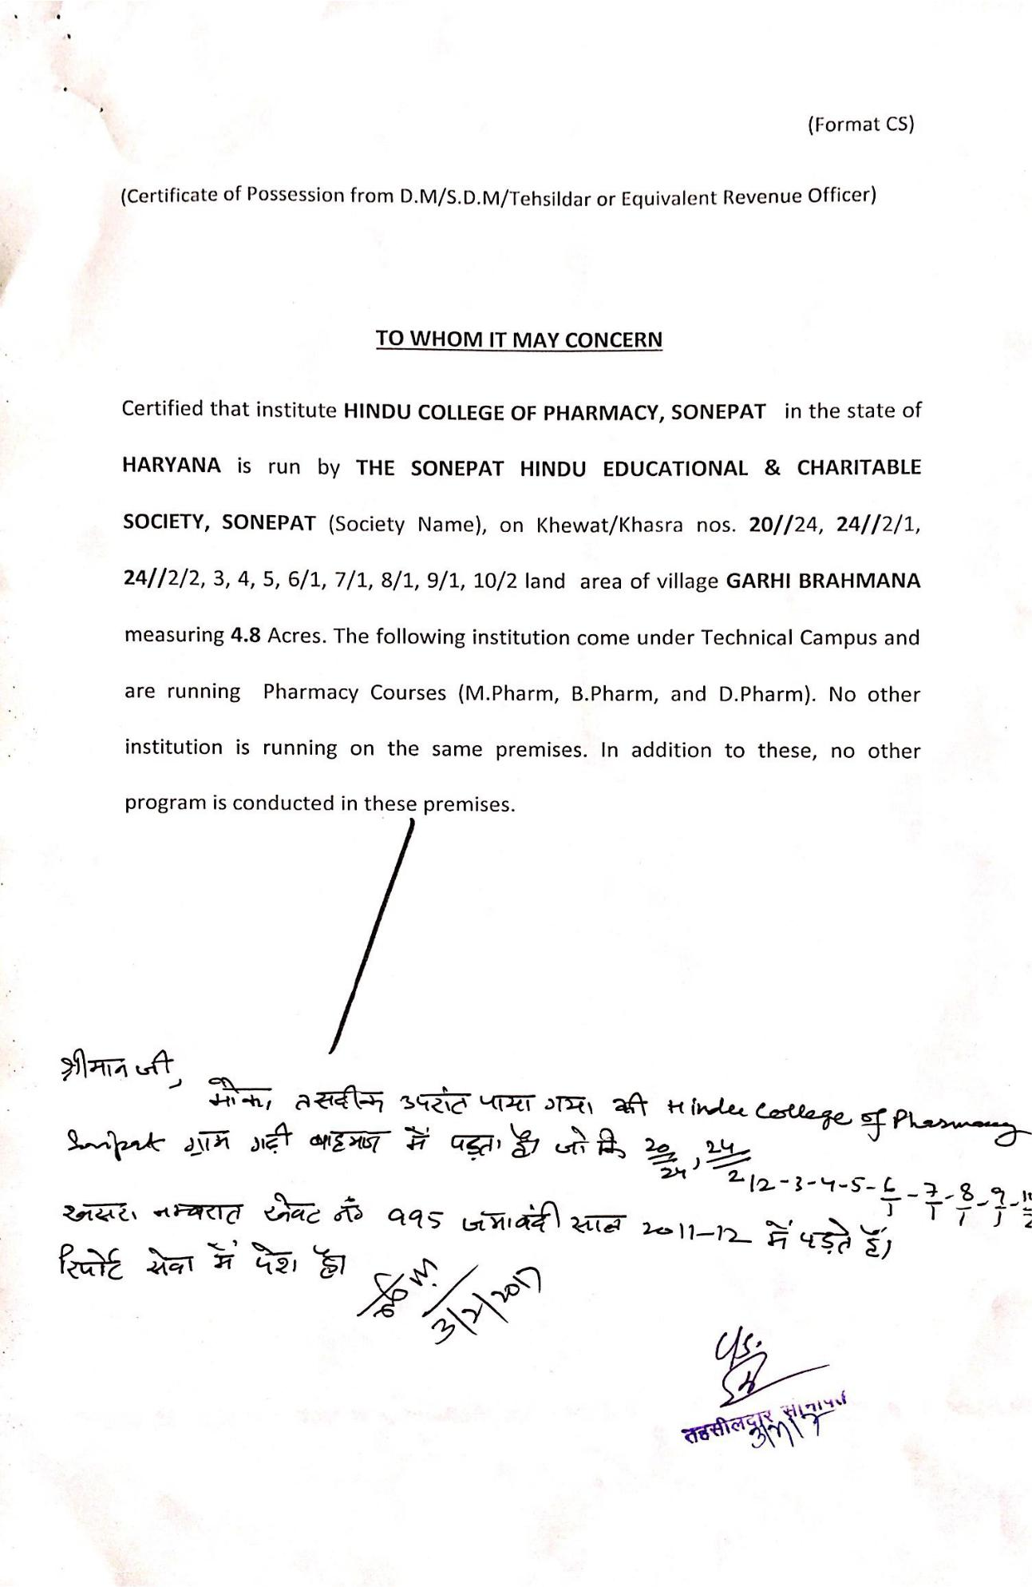

Annexure XIX

Occupancy Certificate

Annexure XX

Fire Safety Certificate

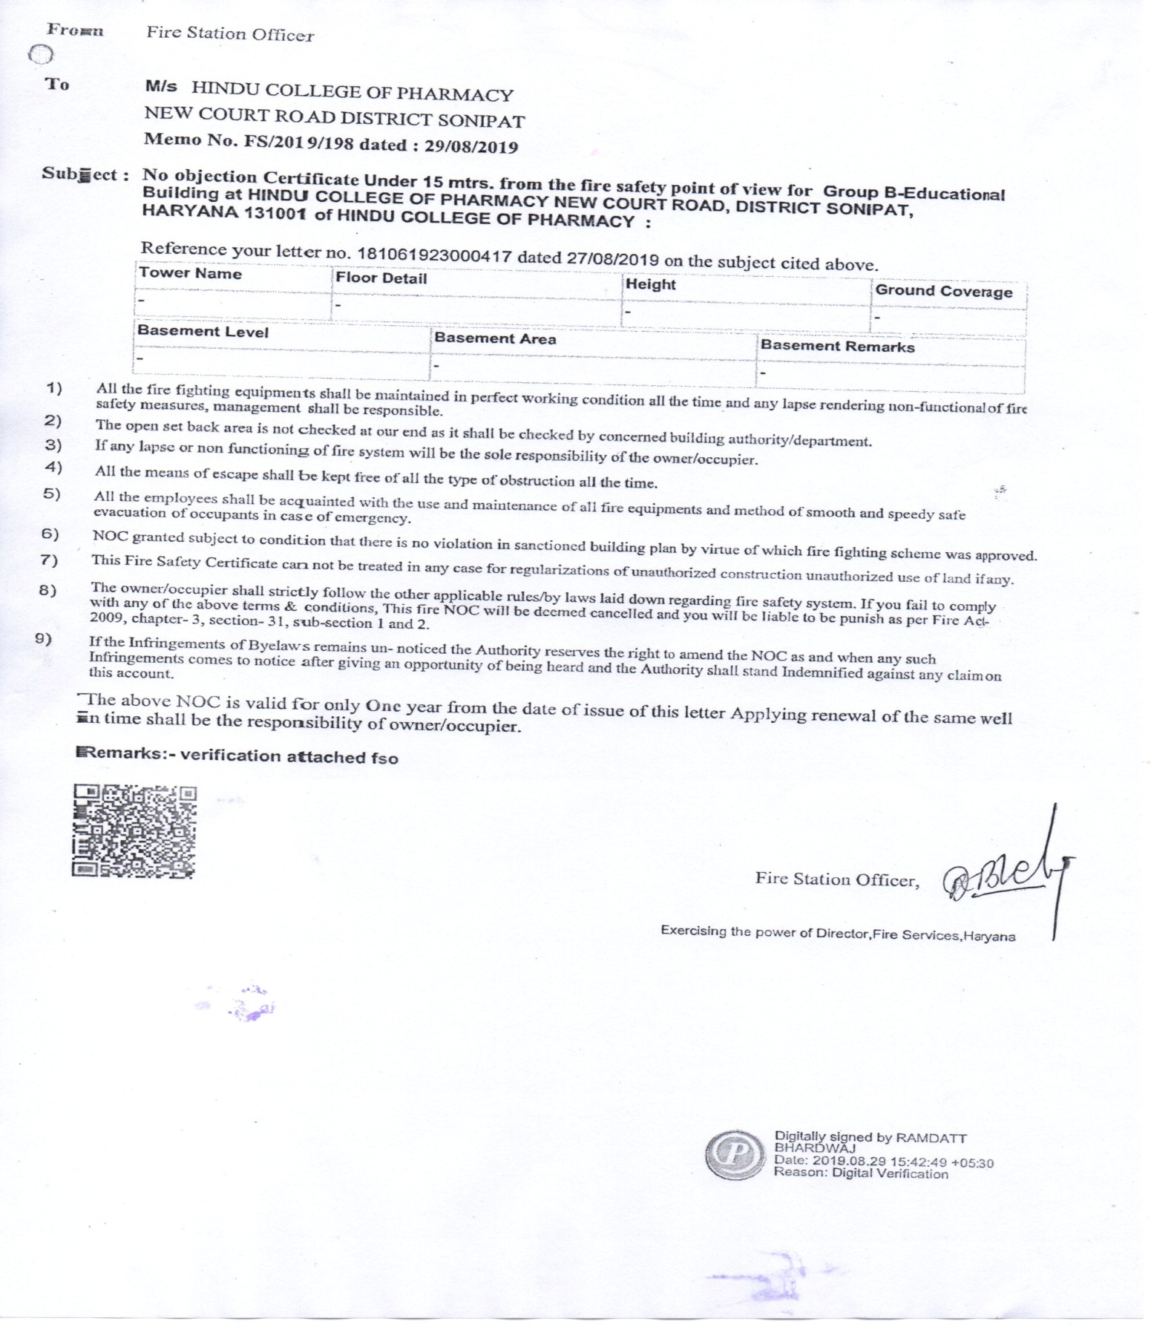
Annexure XXI

List of Library books/ Titles/ Journal

HINDU COLLEGE OF PHARMACY, SONEPAT
LIST OF JOURNALS

Sr. No | Name of Periodicals
1 | Pharma Times
2 | IJPS
3 | Indian Journal of Pharm Education & Research
4 | Indian Drugs
5 | Indian Journal of Pharmacology
6 | Journals of Advanced Pharmatech & Research
7 | Pharmacognosy Research
8 | Pharma Review
9 | Inventi Impact: Pharmatech
10 | Inventi Impact: NDDS
11 | Asian Journal of Pharmaceutics
12 | Online Journal Delnet
13 | Research Journal: Pharm Sciences & Research
14 | Trends in Pharmaceutics and Nanotechnology
15 | Journal of Pharma & Drug Regulatory Affairs
16 | Research & Review : A Journal of Pharm Sciences
17 | Research & Review : A Journal of Health Professional
18 | Research & Review: A Journal of Drug Design & Discovery
19 | Trends in Drug Delivery
20 | Journal of Advances in Biopharmaceutics and Pharmacovigilance

HINDU COLLEGE OF PHARMACY, SONEPAT

Total No of Titles Present in the Library

S. No. Subject No of Titles

1. Pharmacology 184
2. Pharmaceutical Chemistry 194
3. Pharmacognosy 105
4. Pharmaceutical Biology 28
5. Pharmaceutical Arithmatics 13
6. Computer Application 37
7. Environmental Studies 02
8. Pharmaceutics 185
9. General Books 151
10. Reference Books 379
11. Communication Skills 1
-------------------------------------------------------------------------------------------------
Total 1279

HINDU COLLEGE OF PHARMACY, SONEPAT

List of books (Subject wise)

1. Pharmacology 4427
2. Pharmaceutical Chemistry 5004
3. Pharmacognosy 2235
4. Pharmaceutical Biology 283
5. Pharmaceutical Airthmatics 223
6. Computer Applications 302
7. Environmental Studies 170
8. Pharmaceutics 7712
9. General Books 1334
10. Reference Books 657
11. D. Pharmacy Book Bank Books 656
12. B. Pharmacy Book Bank Books 1166
13. Communication Skills 25

TOTAL 24194
Annexure XXII

Specialized Lab

The college has spacious labs with latest equipments to cater the needs of the students.
Some of the available sophisticated instruments are:

- Digital Dissolution Apparatus
- Ultracentrifuge
- Stability Chamber
- H.P.L.C.
- Brookfield viscometer
- Probe sonicator
- Lyophilizer
- Micro Centrifuge
- Refrigerated Centrifuge
- Tablet machine (16 stations)
- Homogenizer
- Bulk density apparatus
- FT-IR Spectrophotometer
- Double Beam UV Spectroscopy
- Hardness tester
- Friability test apparatus
- Franz diffusion cell
- Disintegration tester (6 basket)
- Electric shaker
- Auto deionizer
- Sieve sets
- Laminar flow
- Vortex Mixer
- Colorimeter with eight filters
- Rotary Vacuum Evaporator
- B.O.D. Incubator
- Digital Ovens
- Refractometer
- Redwood Viscometer
- Deep Freeze
- Chemical Biochemistry Analyzer
- Electrophoresis Unit
- Conductivity meter
- Digital Balance

- Digital Plethysmometer for measuring Paw Inflammation

- Actophotometer
- Rota Rod Apparatus
- Colony Counter
- Radial Senior Rotary Microtome
- Binocular Microscope with Various Attachments
- Projection Microscopes

Annexure XXIII

Research Committee/ Innovation Cell

S.No | Name | Position | Qualification | Present Position/Qualification | Phone No. | E mail
01. | Dr. Saroj Jain | Chairperson | M. Pharm., Ph. D. | Principal | 9868164558 | sarojhcp@yahoo.com
02 | Sh. Sunil Kumar Batra | Memebr | M. Pharm | Associate Professor | 9868300648 | sunilkbatra@yahoo.com
03 | Dr. Dinesh Kaushik | Memebr | M.Pharm, Ph.D | Associate Professor | 9812307000 | Dineshkaushik07@yahoo.com
04 | Dr. Arun Mittal | Member | M. Pharm.  Ph.D | Associate Professor | 9354806431 | Mittalarun07@rediffmail.com

Annexure XXIV

Social Media cell

S.No | Name | Position | Qualification | Present Position/Qualification | Phone No. | E mail
01. | Dr. Saroj Jain | Chairperson | M. Pharm., Ph. D. | Principal | 9868164558 | sarojhcp@yahoo.com
02 | Mrs. Jyoti | Member | M. Pharm | Assistant Professor | 9896459487 | jyoti.sumit19@gmail.com
03 | Sh. Sangeet Kumar | Member | M. Pharm | Assistant Professor | 9813033239 | Sharmasangeet1489@gmail.com

Annexure XXV

Academic Time Table

HINDU COLLEGE OF PHARMACY, SONEPAT
TIME-TABLE (SESSION 2020 - 21) w. e .f. 10/08/2020
CLASS- B. PHARMACY 7th semester

Day / Time | 9.40 to 10.25 | 10.25 to 11.10 | 11.10 to 11.55 |  | 11.55 to 12.40 | 12.40  TO  1.00  L  U  N  C  H | 1.45 to 4.00
Monday | Lib | NDDS | PP |  | IMA |  | IMA Practical  A
Tuesday | IMA | LIB | IP |  | IP |  | IMA Practical  B
Wednesday | IMA | IP |  | NDDS | PP |  | IMA Practical  C
Thursday | PP | IP |  | IMA | NDDS |  | Project Work
Friday | NDDS | PP |  | IMA | LIB |  | Project Work

HINDU COLLEGE OF PHARMACY, SONEPAT
TIME-TABLE (SESSION 2020 - 21) w. e .f. 10/08/2020
CLASS- B. PHARMACY 5th Semester (3rd YEAR)

Day / Time | 9.40 to 10.25 | 10.25 to 11.10 | 11.10 to 11.55 | 11.55 to 12.40 | 12.40  To  1.00  L  U  N  C  H | 1.00 to1.45 | 1.45 to 2.30 | 2.30 to 3.15 | 3.15 to 4.00
Monday | Ph. Cology Ph. Cog Form. Ph.  A B C |  |  | Ph. Jurisp |  | Ph. Cology | Ph.Cognosy | Med Chem | Lib
Tuesday | -Do- -Do- -Do-  B C A |  |  | Ph. Jurisp |  | Form. Ph | Form. Ph | Ph.Cognosy | Lib
Wednesday | -Do- -Do- -Do-  C A B |  |  | Ph. Cology |  | Med Chem | Ph. Jurisp | Form. Ph | -
Thursday | Juris | Juris | Ph.Cognosy | Form. Ph |  | Ph. Cology | Med Chem | Ph.Cognosy | -
Friday | Lib | Med Chem | Med Chem | Ph.Cognosy |  | Ph. Cology | Ph. Cology | Form. Ph | -

HINDU COLLEGE OF PHARMACY, SONEPAT
TIME-TABLE (SESSION 2020 - 21) w. e .f. 10/08/2020
CLASS- B. PHARMACY 3rd SEMESTER (SECOND YEAR)

Day / Time | 9.40 to 10.25 | 10.25 to 11.10 | 11.10 to 11.55 | 11.55 to 12.40 | 12.40  To  1.00  L  U  N  C  H | 1.00 to1.45 | 1.45 to 2.30 | 2.30 to 3.15 | 3.15 to 4.00
Monday | Ph. Engg PP Org Chem  A B C |  |  | PP |  | Org | Micro | Ph. Engg | -
Tuesday | ---Do--- -Do- -Do-  B C A |  |  | PP |  | Org | Ph. Engg | Lib | Lib
Wednesday | ---Do--- -Do- ---Do—  C A B |  |  | Micro |  | PP | Ph. Engg | Org | Lib
Thursday | PP | Ph. Engg | Micro | Org |  | Micro  A
Friday | Micro  B |  |  | Micro |  | Micro  C
Saturday | PP | Org | Ph. Engg | Micro

HINDU COLLEGE OF PHARMACY, SONEPAT

TIME-TABLE (SESSION 2020 - 21) w. e .f. 26/10/2020

Day / Time | 9.40 to 10.25 | 10.25 to 11.10 | 11.10 to 11.55 |  | 11.55 to 12.40 | 12.40  TO  1.0  L  U  N  C  H | 1.00 to1.45 | 1.45 to 2.30 |  | 2.30 to 3.15 | 3.15 to 4.00
Monday | Inorg | Ph. Ceutic | Rem. Bio/ Maths |  | HAP |  | Analysis | Ph. Ceutics HAP Analysis  A B C
Tuesday | Rem. Bio/ Maths | Ph. Ceutic | Inorg |  | HAP |  | Analysis | Do Do Do  B C A
Wednesday | Inorg | HAP |  | Ph. Ceutic | Analysis |  | Comm. Skill | Do Do Do  C A B
Thursday | Inorg | HAP |  | Ph. Ceutic | Analysis |  | Comm. Skill | Inorg Rem. Bio Comm. Skill  A B C
Friday | Inorg Rem. Bio Comm. Skill  B upto 12.40 C upto 11.10 A Upto 11.10 |  |  |  |  |  | Inorg Rem. Bio Comm. Skill  C 4.00 A upto 2.30 B Upto 2.30
Saturday | HAP | Ph. Ceutic | Inorg |  | Analysis |  | Rem. Bio/ Maths | Comm. Skill | - |  | -
CLASS- B. PHARMACY 1st SEMESTER (1st YEAR)

HINDU COLLEGE OF PHARMACY, SONEPAT
TIME-TABLE (SESSION 2020 - 21) w. e .f. 26/10/2020
CLASS- D. PHARMACY 1st YEAR

Day/ Time | 9.40 to10.25 | 10.25to11.10 | 11.10to11.55 | 11.55to12.40 | 12.40  TO  1.0  L  U  N  C  H | 1.00 to1.45 | 1.45 to 2.30 | 2.30 to 3.15 | 3.15 to 4.00
Monday | Ph. Ceutic | Ph. Cog | Bio Chem | Chem I |  | Ph. Ceutics I HAP Chem I  A Upto 4.00 B Upto 2.30 C Upto 3.15
Tuesday | Chem I | Ph. Cog | Ph. Ceutic | HE |  | Ph. Ceutic I HAP Chem-1  B C A
Wednesday | HE | Ph. Ceutic | Lib | HAP |  | Ph. Ceutics I HAP Chem I  C A B
Thursday | Bio Chem | Chem I | HAP | Ph. Cog |  | -  Bio Chem Cognosy  A Upto 3.15 B Upto 3.15
Friday | Bio Chem Cognosy B C |  |  | HAP |  | -  Bio Chem Cognosy  C A

HINDU COLLEGE OF PHARMACY, SONEPAT
TIME-TABLE (SESSION 2020 - 21) w. e .f. 10/08/2020
CLASS- D. PHARMACY 2nd YEAR
TIME/DAY | 9.40 to10.25 | 10.25to11.10 | 11.10 to11.55 | 11.55 to 12.40 | 12.40  TO  1.0  L  U  N  C  H | 1.00 to1.45 | 1.45 to 2.30 | 2.30 to 3.15 | 3.15 to 4.00
Monday | Ph. Cology Ph.Chem II  A Upto 11.10 B |  |  | Hosp Pharm |  | P. CeuticsII | Juris( | - | -
Tuesday | -Do- -DO-  B A |  |  | Ph. Chem II  (DS) |  | P. Ceutic II | Juris | - | -
Wednesday | Lib | P. Chem II | DSBM | Ph.Ceutics II |  | Hosp Pharm | DSBM | - | -
Thursday | Ph. Chem II | Lib | DSBM | Ph. Cology |  | Hosp. Ph. Ceutic II A Upto 2.30 B Upto 4.00 pm
Friday | Ph. Chem II | Hosp Pharm | Ph. Cology | Ph. Cology |  | Hosp. Ph. Ceutic II  B Upto 2.30 A Upto 4.00 pm

HINDU COLLEGE OF PHARMACY, SONEPAT
TIME-TABLE (SESSION 2020 - 21) w. e .f. 26/10/2020
CLASS- M. PHARMACY 1st SEMESTER (PHARMACEUTICS)
Time/Day | 9.40 to 10.25 | 10.25 to 11.10 | 11.10 to 11.55 | 11.55 to 12.40 | 12.40  TO  1.0  L  U  N  C  H | 1.00 to1.45 | 1.45 to 2.30 | 2.30 to 3.15 | 3.15 to 4.00
Monday | Mod. Pharm. | MAT | MAT | DDS |  | Lib | Reg. Affa. | Seminar
Tuesday | Library | DDS | Mod. Pharm. | MAT |  | Reg. Affa. | Seminar  Upto 3.15
Wednesday | Mod. Pharm. | MAT | DDS | DDS |  | Mod. Pharm. | Reg. Affa. | -
Thursday | Practical |  |  |  |  | Practical |  | Seminar
Friday | Practical |  |  |  |  | Practical |  | Seminar

HINDU COLLEGE OF PHARMACY, SONEPAT
TIME-TABLE (SESSION 2020 - 21) w. e .f. 10/08/2020
CLASS- M. PHARMACY 3rd SEMESTER (PHARMACEUTICS)
Time/Day | 9.40 to 10.25 | 10.25 to 11.10 | 11.10 to 11.55 | 11.55 to 12.40 | 12.40  TO  1.0  L  U  N  C  H | 1.00 to1.45 | 1.45 to 2.30 | 2.30 to 3.15
Tuesday | RM | RM | Jour. club | Jour. club |  | - | - | --
Saturday | Jour. club | Jour. club | Jour. club | - |  | RM | RM | RM

Annexure XXVI

Teaching Load
S.No | Name | Qualification | Department | Experience | Working Load
1. | Dr. Saroj Jain | M. Pharm, Ph. D | Pharmaceutics | 32 | 6
2 | Sh. S.K.Batra | M. Pharm | Pharmaceutics | 31 | 16
3 | Dr. Manju Kamra | M.Pharm, Ph.D | Pharma chemistry | 30 | 19
4 | Dr. Dinesh Kaushik | M. Pharm, Ph. D | Pharmaceutics | 25 | 18
5 | Dr. Bharat Bhushan | M. Pharm, Ph. D | Pharma chemistry | 16 | 18
6 | Dr. Rahul Sharma | M. Pharm, Ph.D | Pharmaceutics | 14 | 16
7 | Dr. Arun Mittal | M. Pharm, Ph. D | Pharmacognosy & Phythochemistry | 15 | 16
8 | Mrs. Seema Rohilla | M. Pharm, Ph. D | Pharmaceutics | 9 | 17
9 | Mrs. Preeti Garg | M. Pharm | Pharmacognosy | 7 | 16
10 | Miss Shilpa Jain | M. Pharm | Pharma Chemistry | 5 | 18
11 | Sh. Sangeet Kumar Sharma | M. Pharm | Pharmaceutics | 5 | 18
12 | Sh. Vishnu Dutt | M.C.A | Computer Science | 12 | 16
13 | Mrs. Jyoti | M. Pharm | Pharmacognosy & Phythochemistry | 9 | 16
14 | Sh Naveen | M. Pharm | Pharmaceutics | 3 | 17
15 | Sh. Vineet Vashisth | M. Pharm | Pharmaceutics | 1 | 16
16 | Sh. Birender Singh | M. Pharm | Pharma Chemistry | 6 | 18
17 | Miss Reetu Rani | M. Pharm | Pharmaceutics | 1 | 18
18 | Miss Tanya Gupta | M. Pharm | Pharma Chemistry | 1 | 17
19 | Miss Sakshi Garg | M. Pharm | Pharmaceutics | 1 | 16
20 | Sh. Amit Kaushik | M. Pharm | Pharmaveutics | 02Month | 16
21 | Sh. Kapil Sharma | M. Pharm. | Pharmacognosy | 01 Month | 17
22 | Sh. Sunil Jain | M. Pharm. | Pharmaceutics | 02 Month | 17
23 | Sh. Sangeet Tiwari | M. Pharm., | Pharmaceutics | 02 Month | 16
24 | Sh. Rajesh Verma | M.Pharm | Pharmacognosy | 02 month | 12
25 | Miss Jasmine Batra | M.Pharm | Pharmacology | 02 months | 14
26 | Mr. Tarun Kumar | M.Pharm | Pharmacology | 02 months | 14

Annexure XXVII

Enrollment of students in last three years

S.No | Course | Approved Intake |  |  | Actual Intake
 |  | 2018-19 | 2019-20 | 2020-21 | 2018-19 | 2019-20 | 2020-21
1 | D.Pharmacy | 60 | 60 | 60 | 60 | 60 | 60
2 | B.Pharmacy | 60 | 60 | 60 | 60 | 60 | 60
3 | B.Pharmacy (Leet) | 06 | 06 | 06 | 06 | 06 | 06
4 | Master in Pharmacy (Pharmaceutics) | 09 | 09 | 09 | 09 | 08 | 09

Annexure XXVIII

MOU with Industries

S.No | Name of the Company
1 | AFFLATUS PHARMACEUTICALS PVT. LTD., PLOT NO. 766, HSIIDC,RAI- 131029, SONEPAT
2 | ANVIK BIOTECH PVT. LTD., PLOT NO. 793, HSIIDC, RAI- 131029,SONEPAT
3 | ADSILA ORGANICS PVT. LTD., LIWASPUR ROAD, BAHALGARH,SONEPAT
4 | AVALON BIOCARES, PLOT NO. 1861, HSIIDC, RAI- 131029, SONEPAT
5 | MIMS LABORATORIES, PLOT NO. 16, BHARAT PURI- 131001, SONEPAT

Annexure XXIX

LOA and EOA
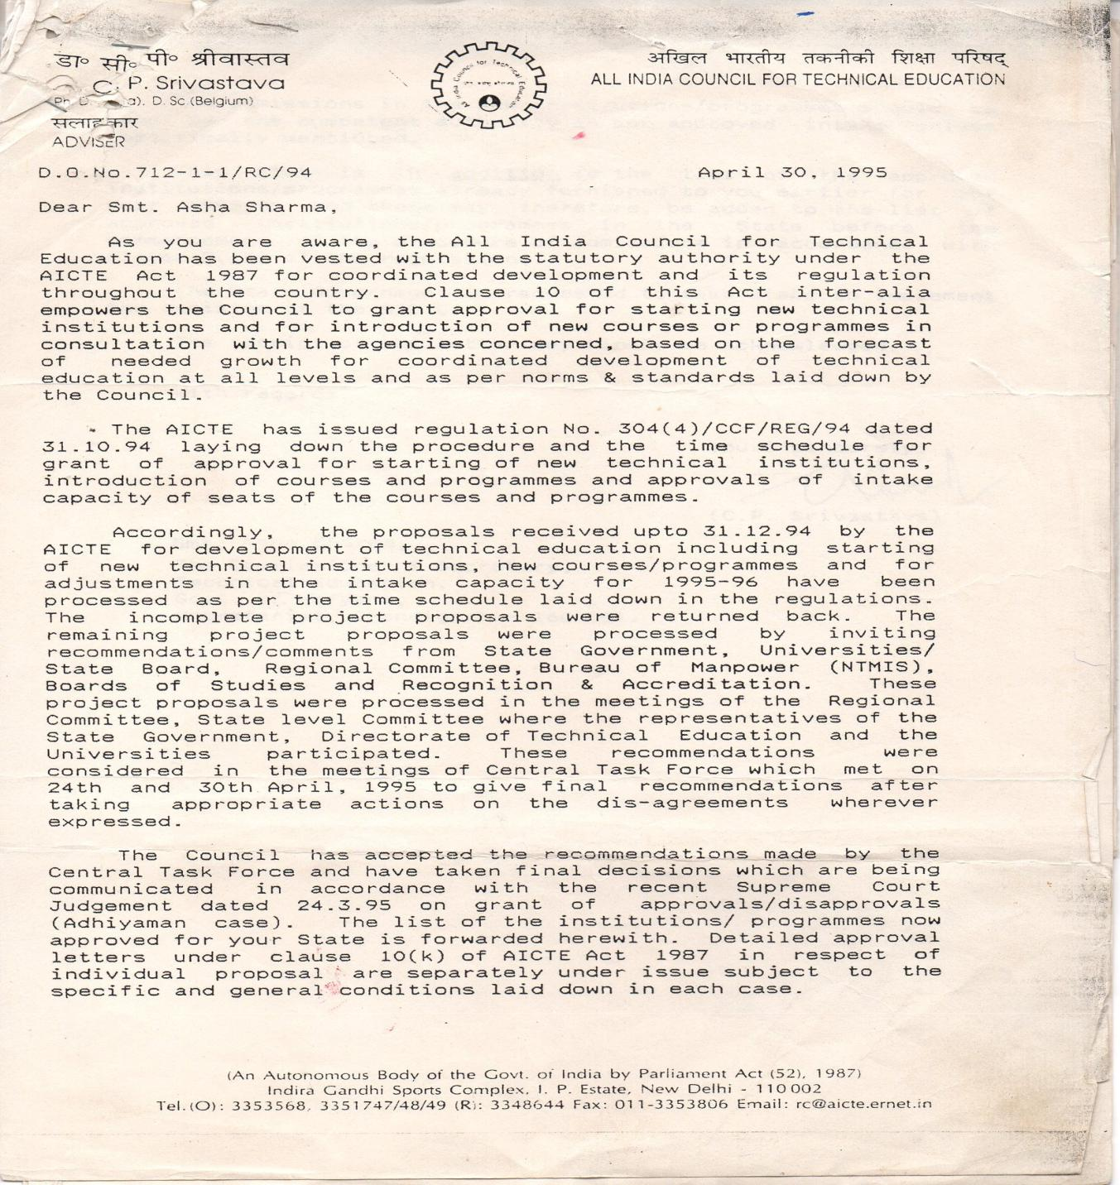
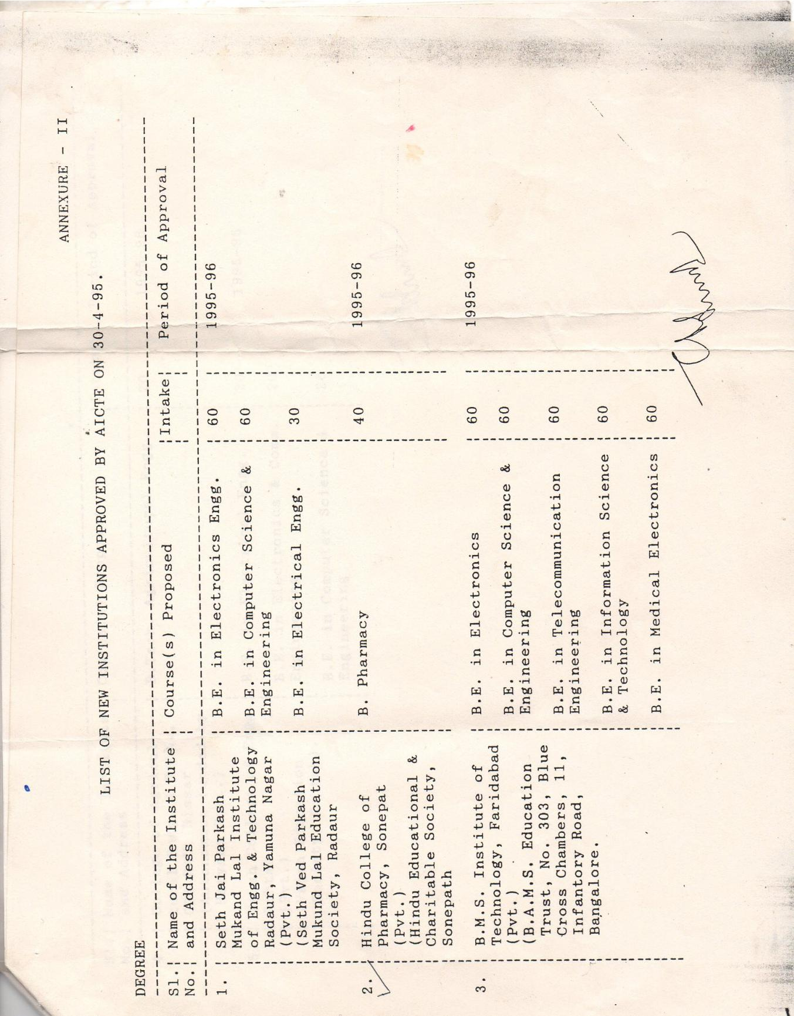

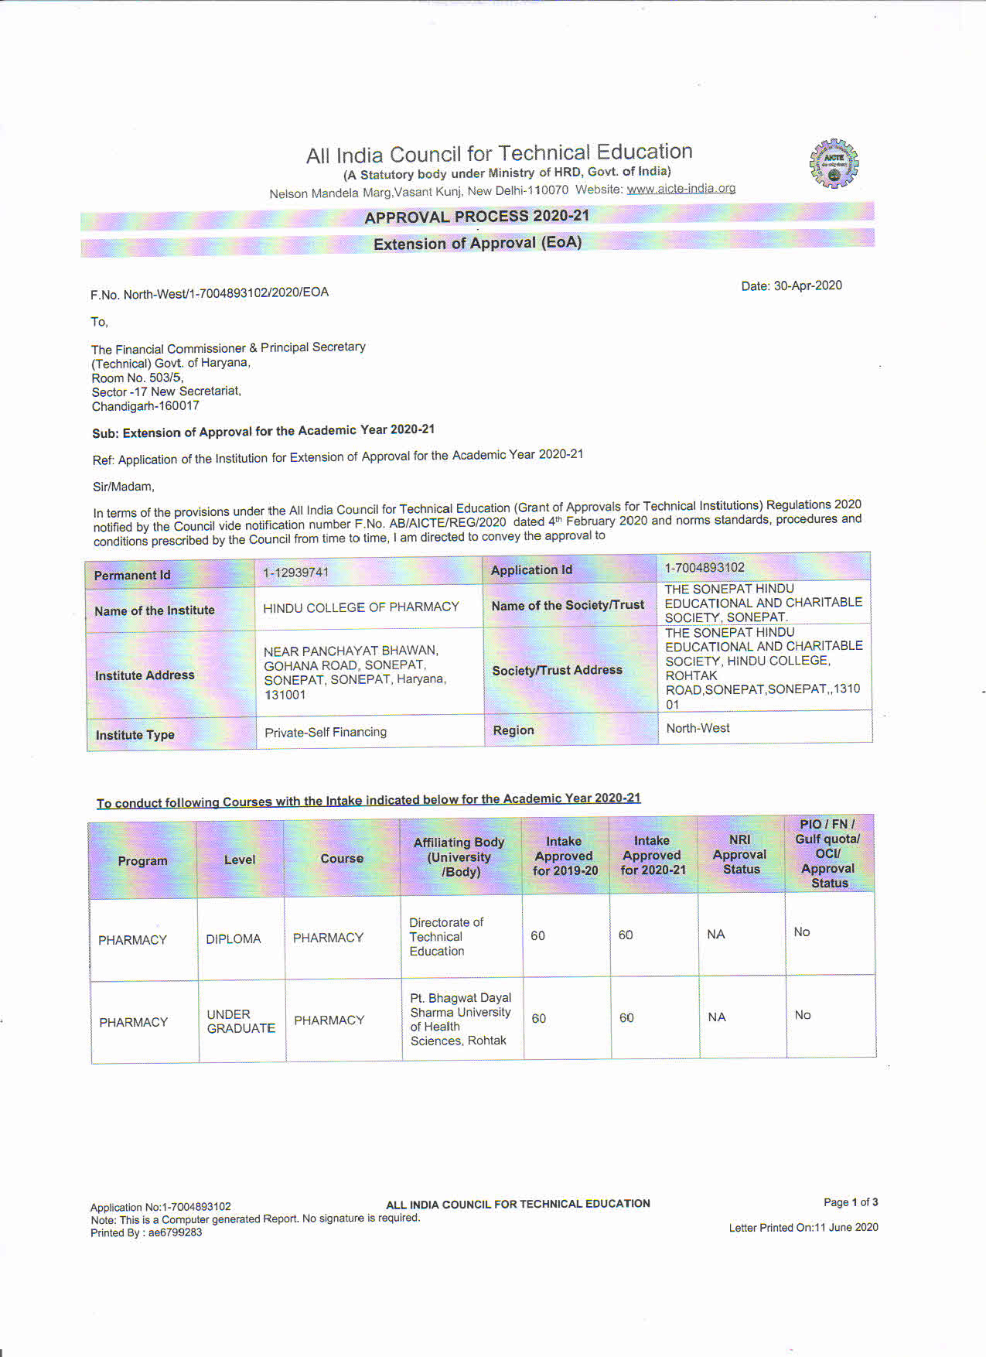
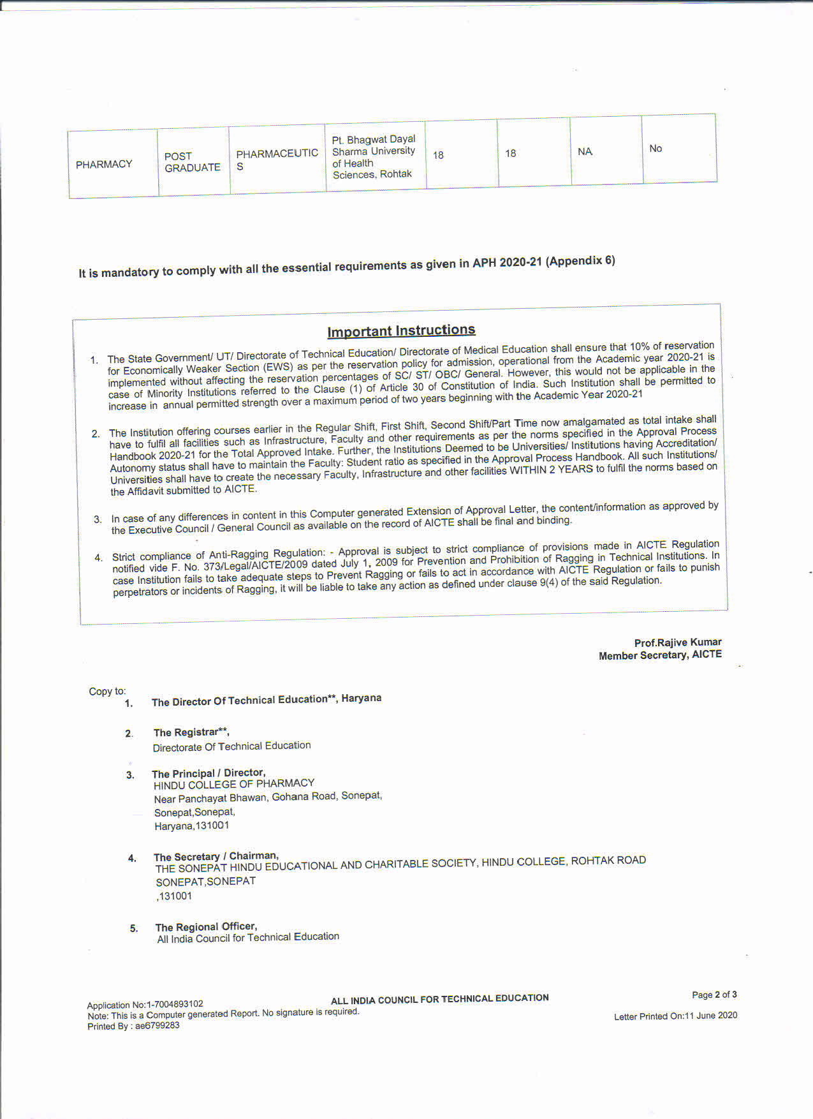
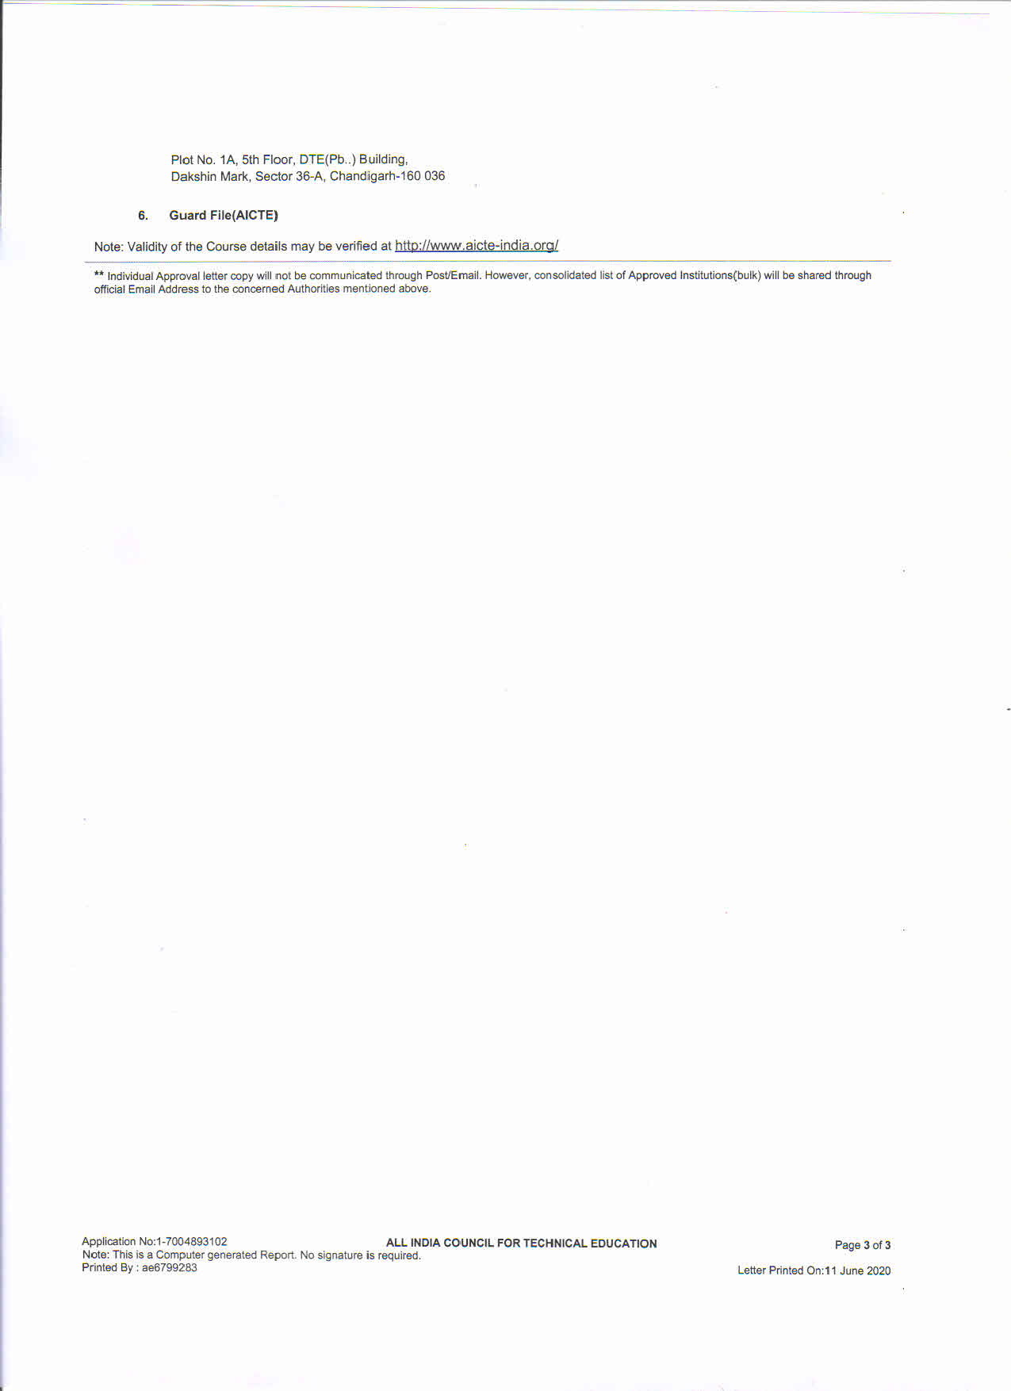

Annexure XXX

Audited Account Statement for last year
